Configuring CUCM VoIP

II

Mason and Hoffman – Period 6-8

Jeffrey Zhang

Purpose

The purpose of this lab is to configure voice-over-ip-protocol (VoIP) within an internal network of a topology using the CUCM (Cisco Unified Communications Manager) to route outbound, while utilizing the internet, and existing phone lines. The goal here is to call outbound onto an external number, and to leave a voicemail. VoIP II covers dialing out of the internal network & dialing into the network, setting a voicemail hold tone, dial tone, and setting a custom voicemail box for the network.

Background

In typical corporate environments, a topology would consist of work phones and voice traffic handling services (such as intercoms, internal phones, etc.). These VoIP devices would most likely run on CUCM as a backbone to their services, so the devices would receive traffic on their end. CUCM would allow for phones to dial within the same network, such as across different floors, several cubicles across (typical work environment), and Link to internal intercom services. All this internal routing is done with pushing very few buttons on the phone registry and avoid the need to use long and arduous “real” phone numbers. In addition, setting voicemail for recipients within the network allows for the employee to receive the memo delivered by other employees without having both parties to be present at the same time.

In addition, the previous lab that I had to perform dealt with making the topology be able to call other local phones within the same network, this time, I’m going to add additional elements to the topology such as the utilization of a custom Ring Tone, the creation of a custom ‘Music on Hold’, the ability to call in and call out of the network, as well as the full utilization of the voice mail module.

Lab Summary

In this lab, we configured a CUCM server within a virtual machine to assign phone numbers independently to 2 Cisco VoIP phones and to allow these 2 phones to call each other with custom numbers. We first loaded the CUCM image file (.iso) into a virtual machine running Red Hat enterprise OS. Through the OS, I accessed the GUI through a web browser to allow for the assigning of the two phone numbers. Afterwards, we tested connectivity by dialing between the two phones within the topology.

The current topology utilized the same topology from the previous lab (Voip I), however, this time, it was required that we integrate the Cisco Unity Communication System module into the topology.

OBJECTIVES:

* Enable Voice mail module
* Configure Call in/Call out capabilities
* Enable and customize the Music on Hold audio
* Enable and customize Ringtones to the network.

====================================

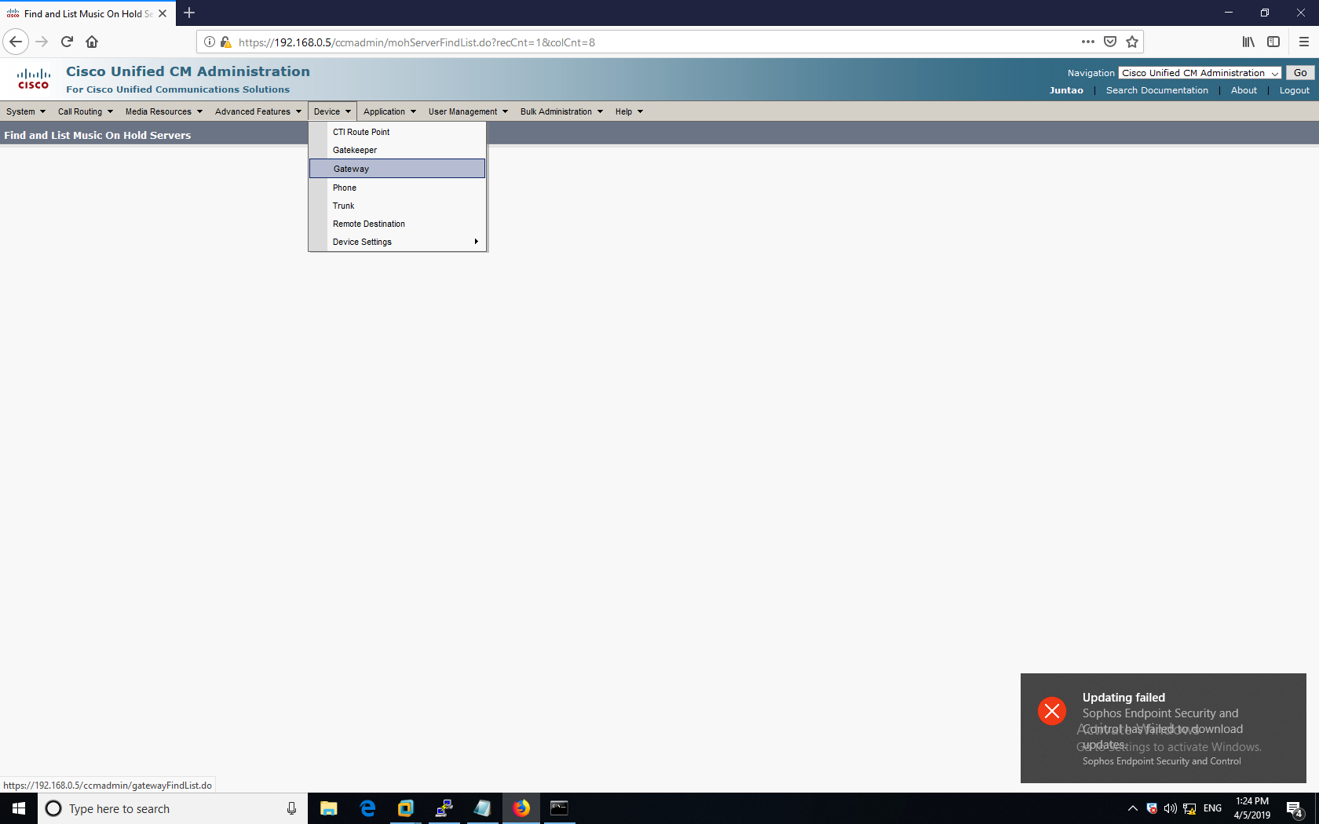

I first set up a gateway for the CUCM.

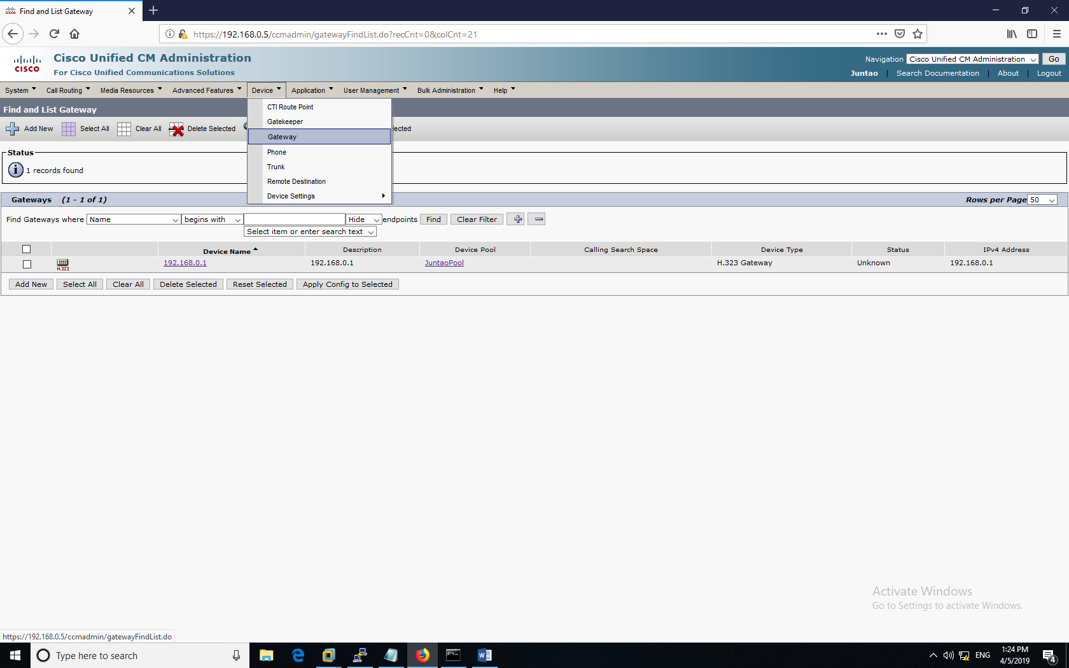

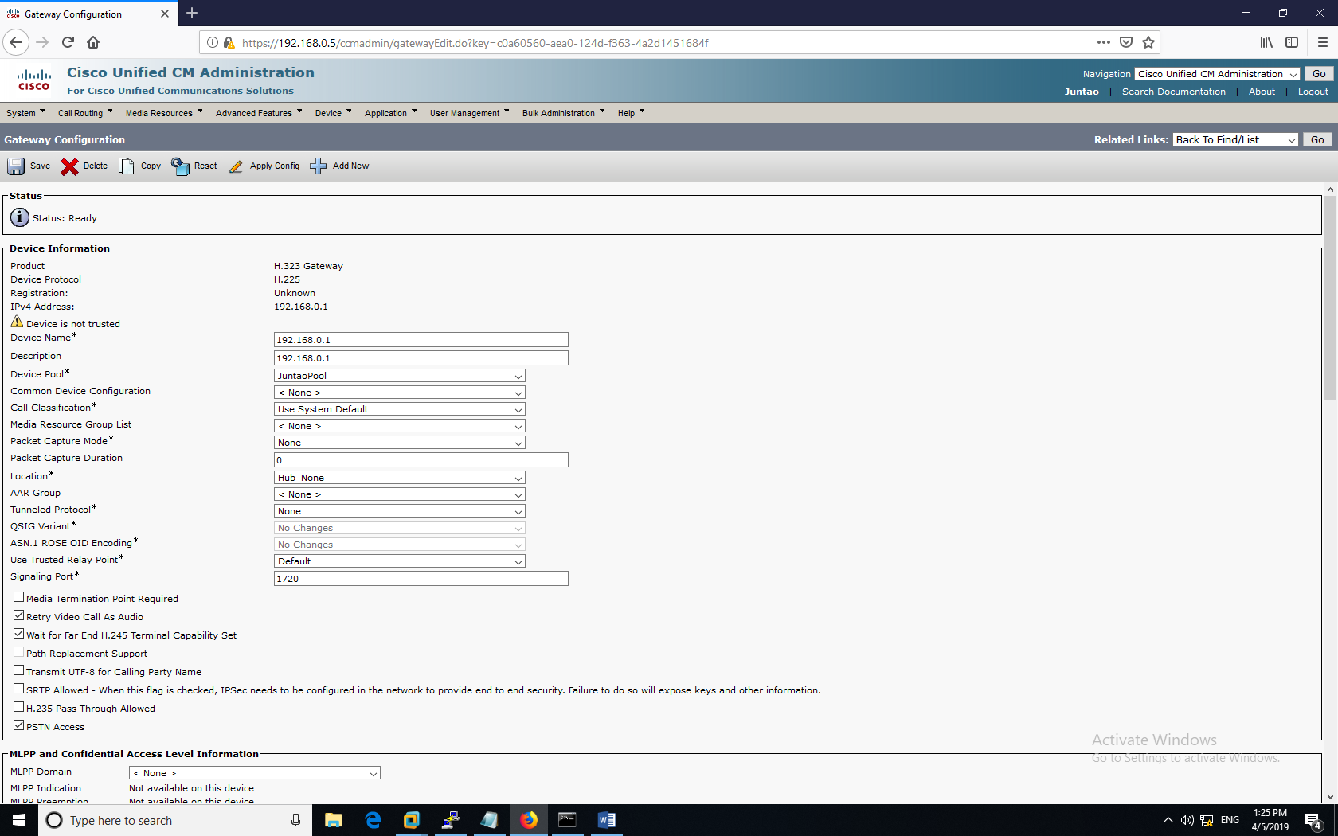

Within this Gateway, I added these configurations.

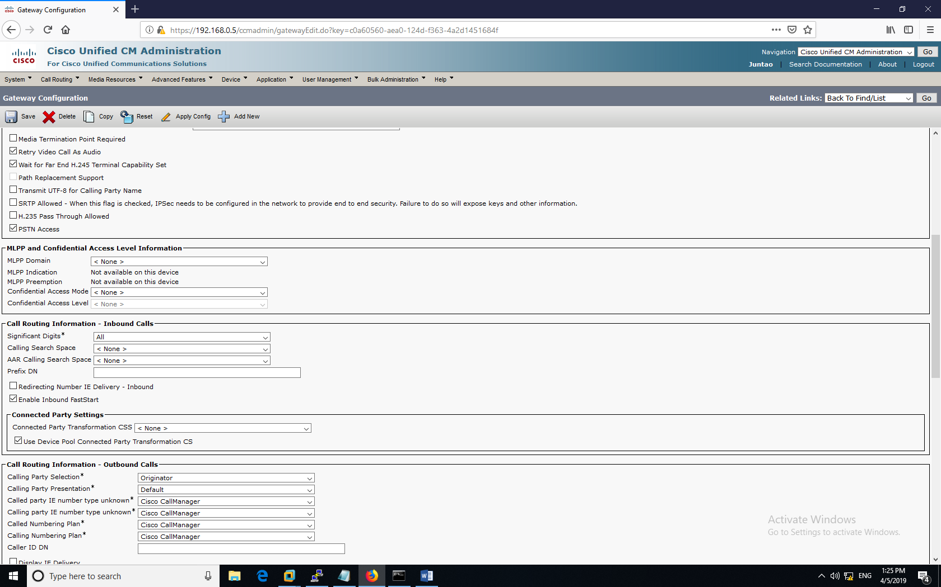

Set the options like the ones displayed above



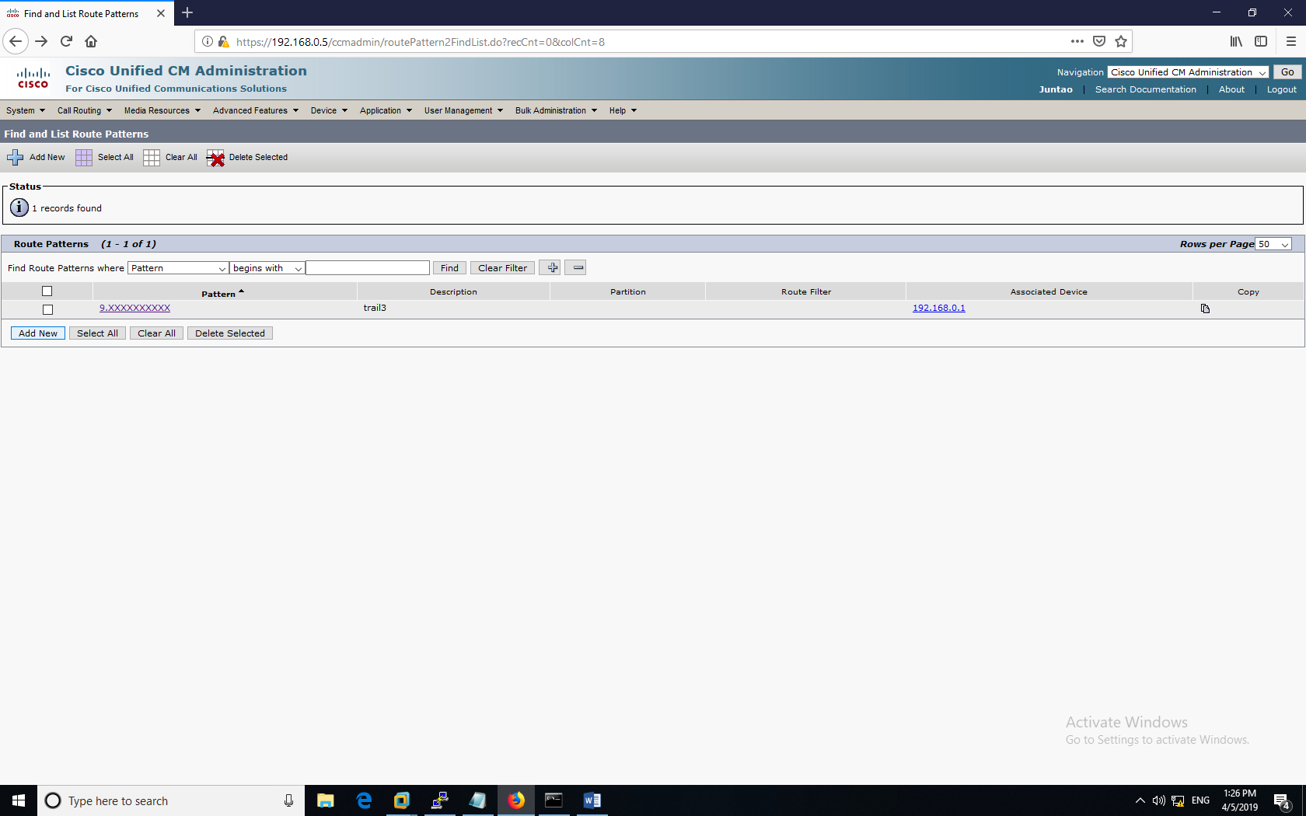

Route patterns set up like so in the above screenshot (For Dial-in, and dial-out)

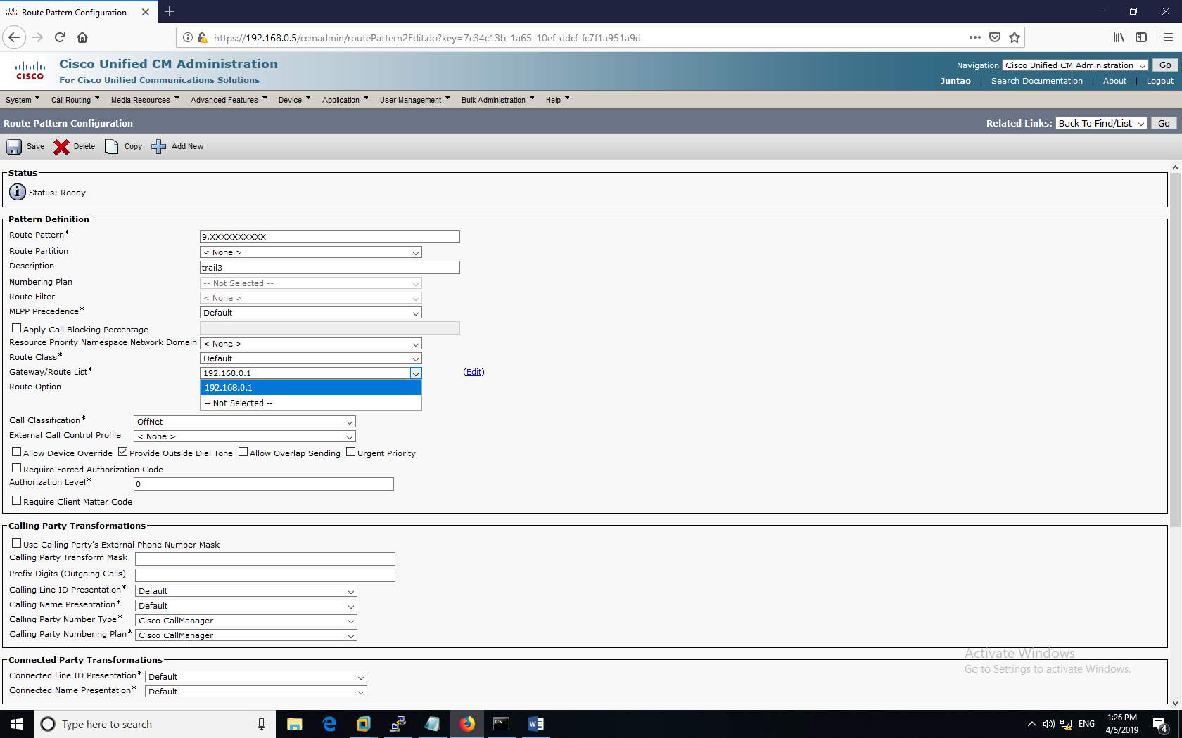

The gateway that was set up within the CUCM has been selected during the Route Definitions.

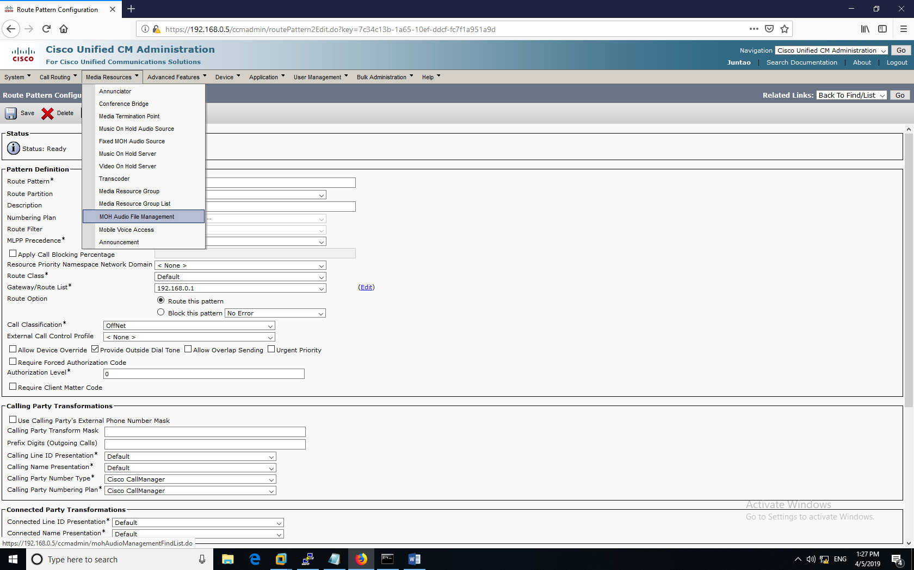

After the Pattern has been configured, Head over to the Audio File Management tab to begin the hold tone management.  
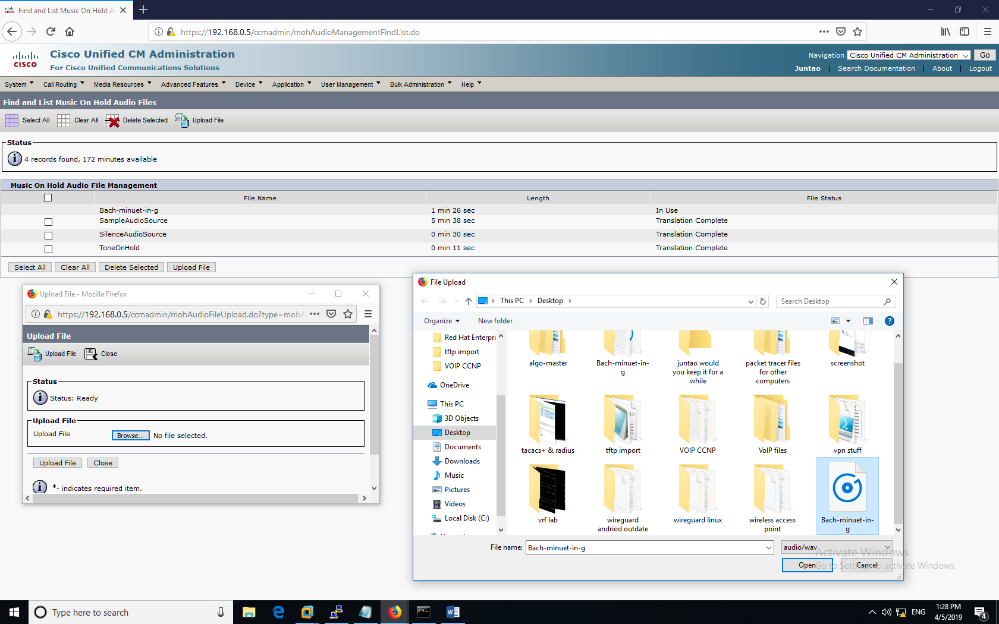

Here, we have an .mp3 compressed audio file. This would be used to be converted to a ‘.RAW’ audio file used by the cisco IP Phones. In this lab, I used audacity to re encode the files.

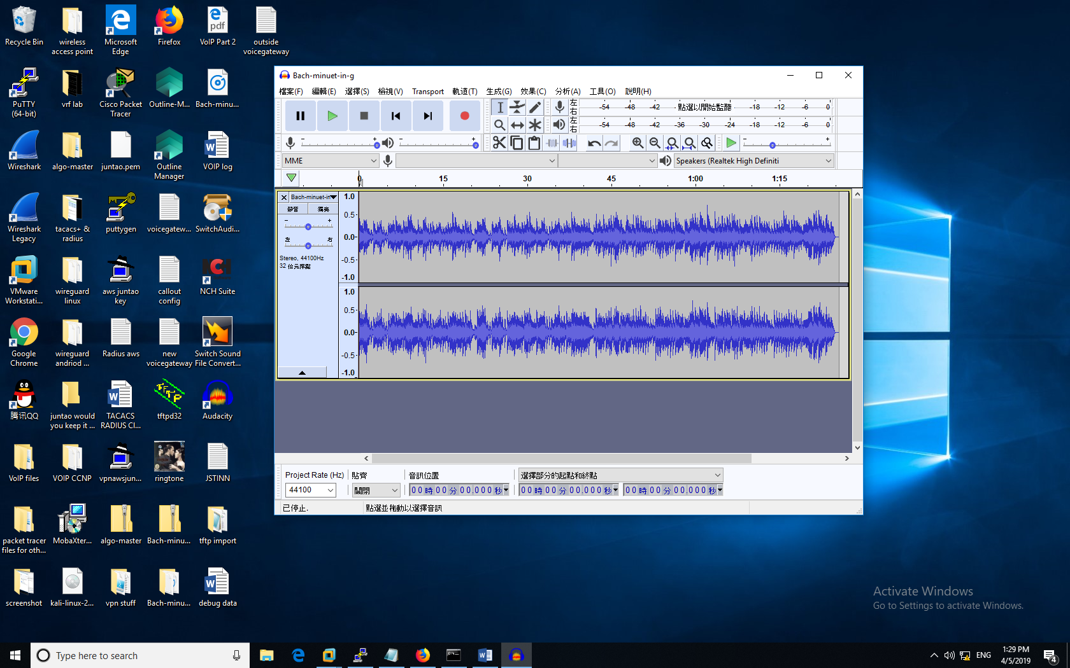

After opening mp3 file within Audacity, I combined both channels into one solid channel. Then I compressed the file down to CD quality for it to work on the IP Phones.

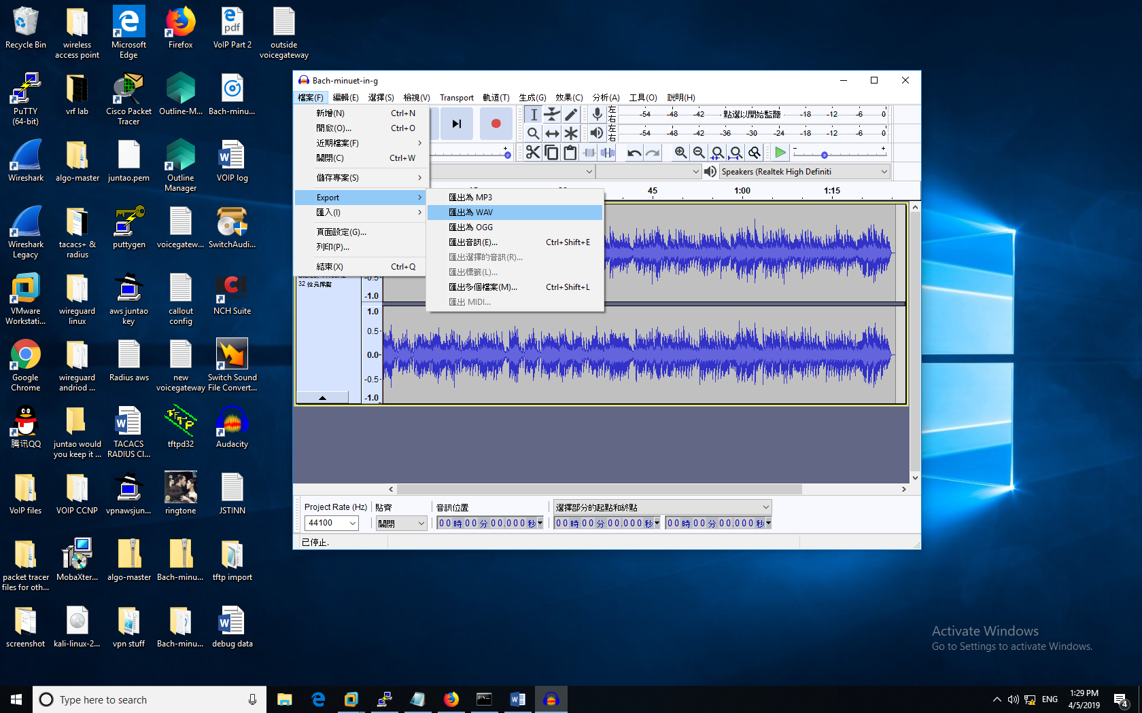

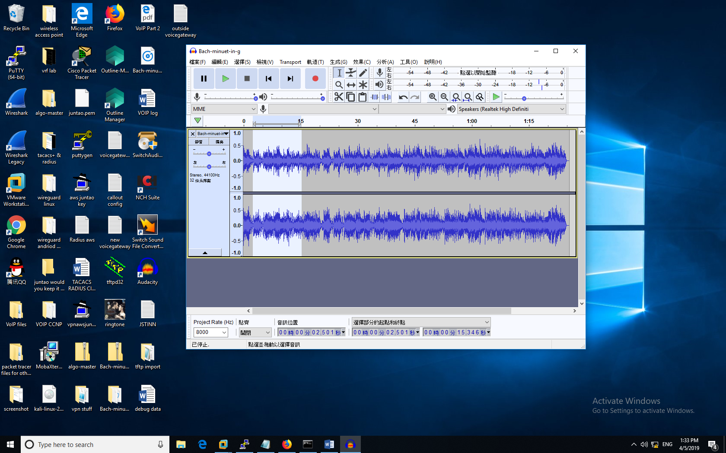

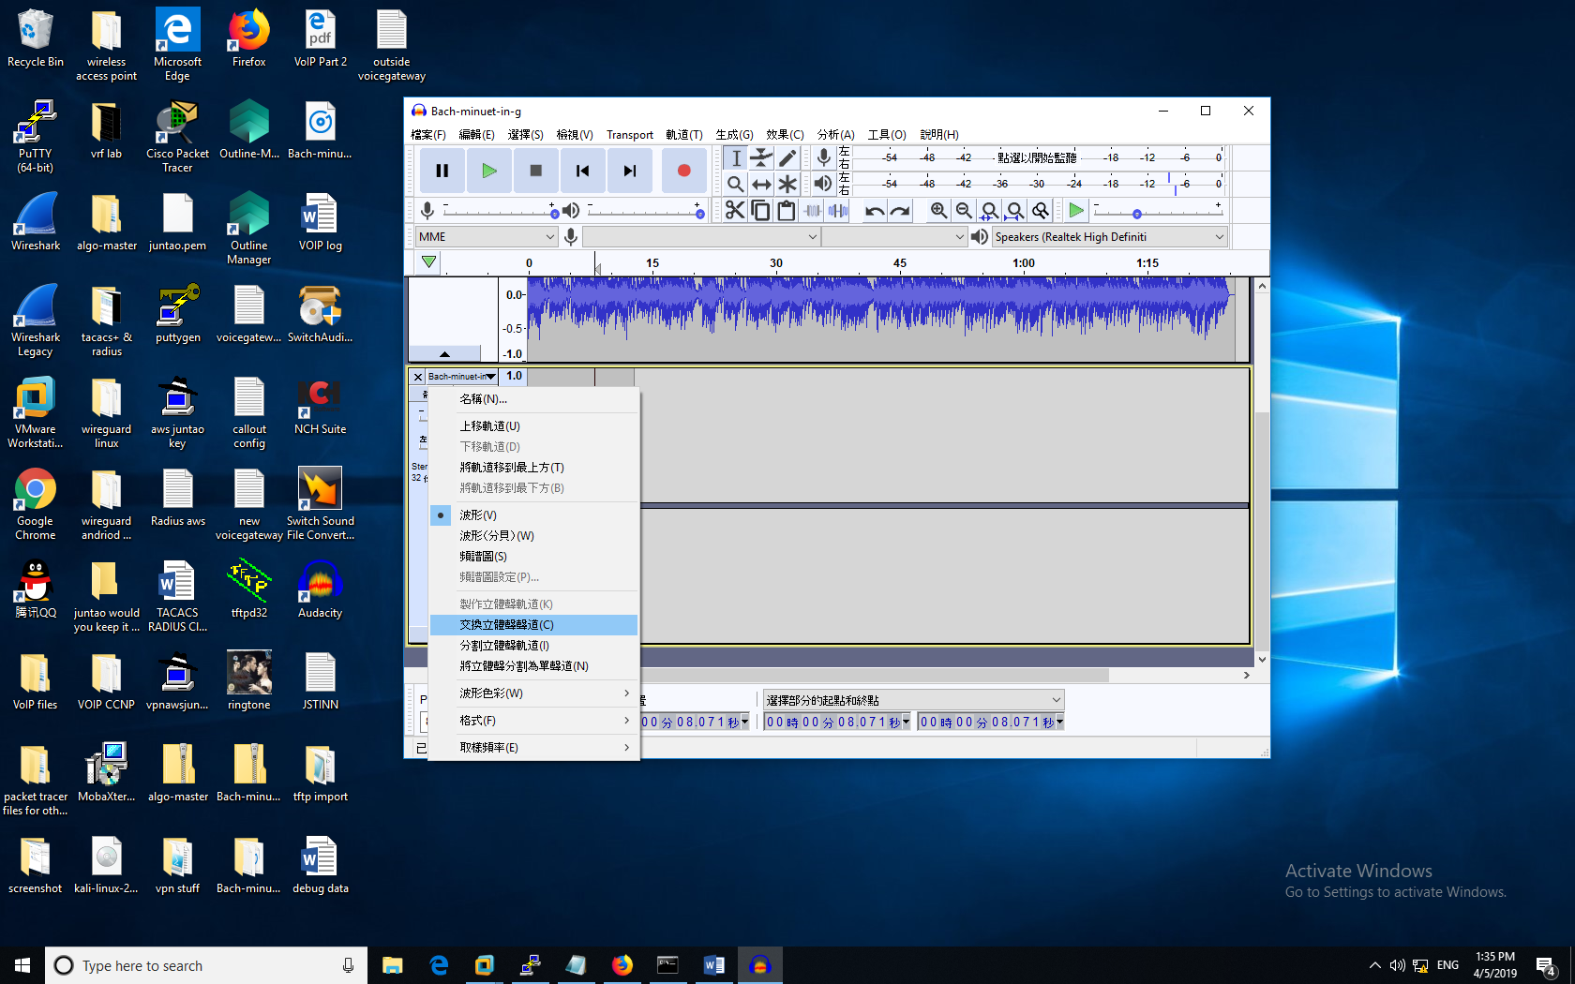

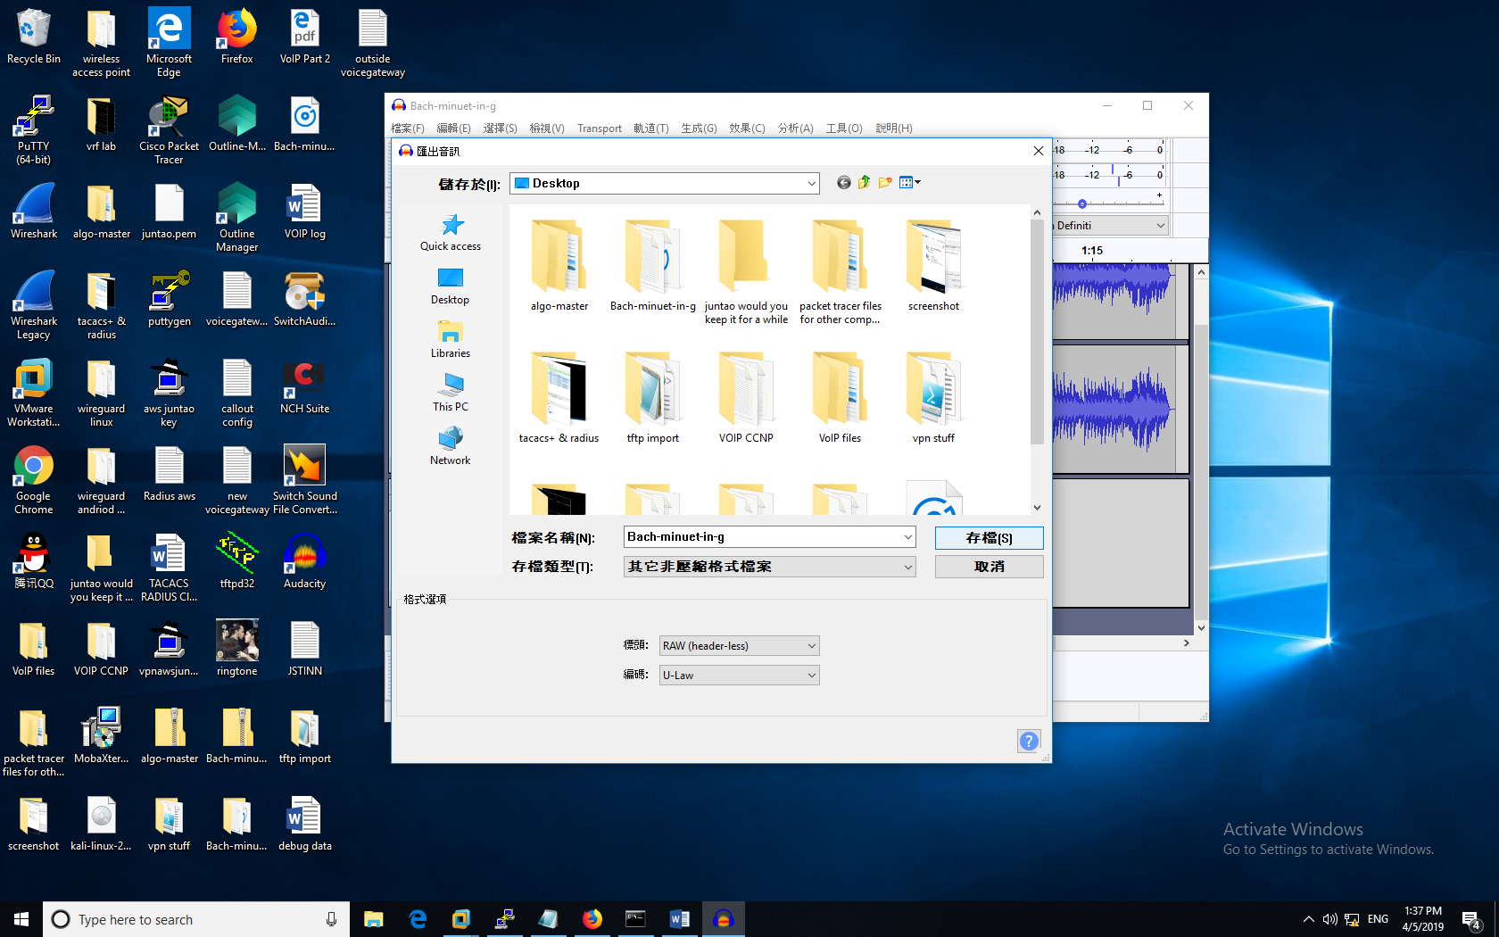

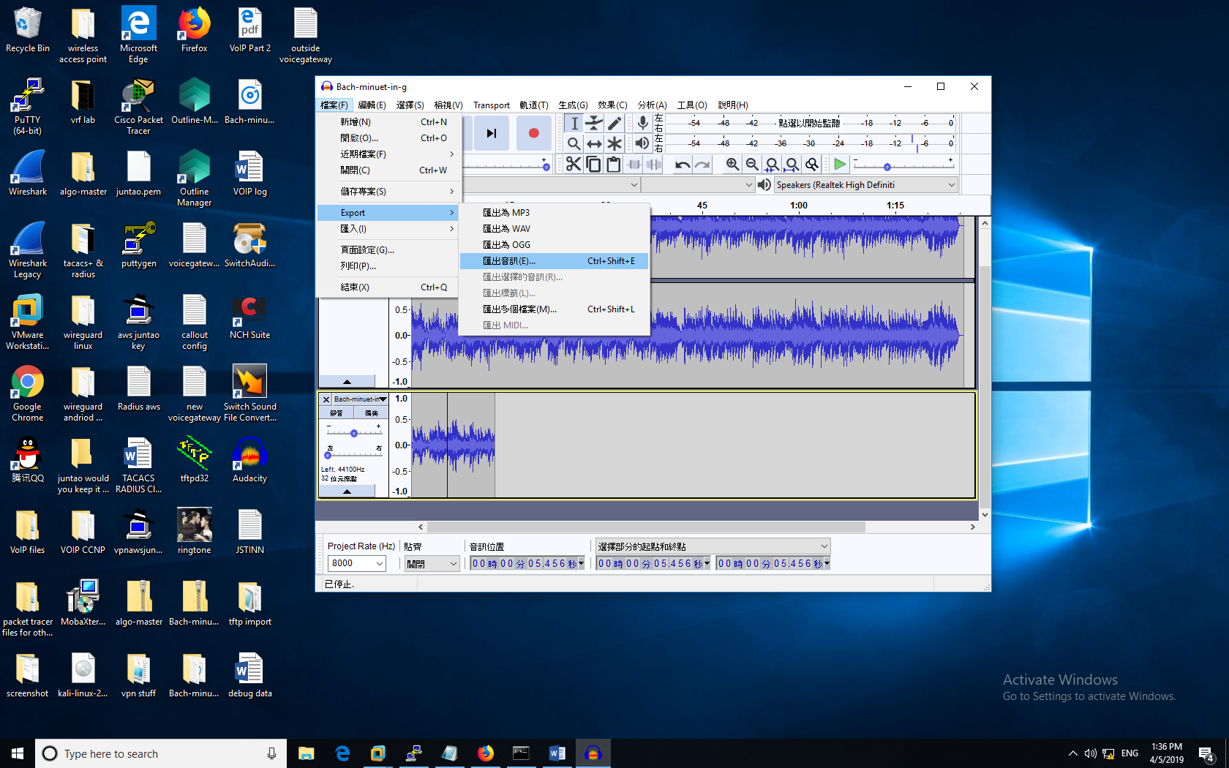

With the Finished RAW file, I uploaded it to the configuration using TFTP software.

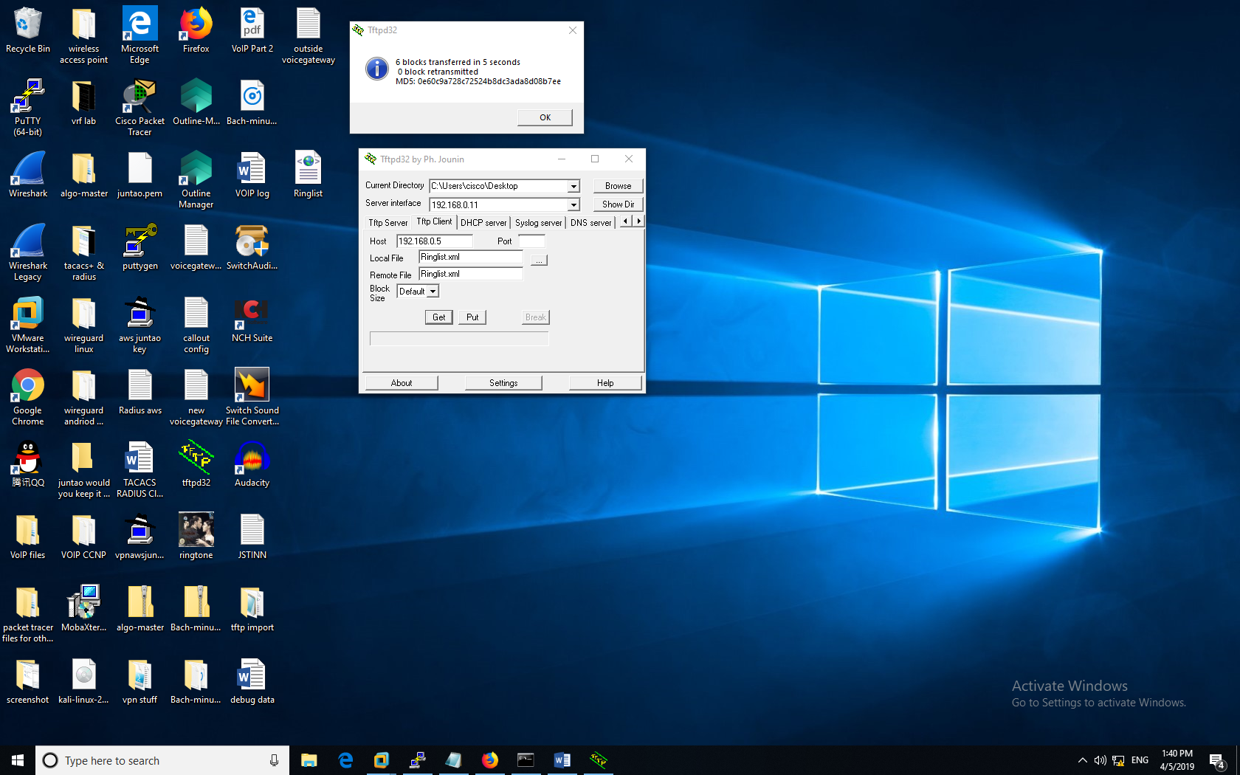

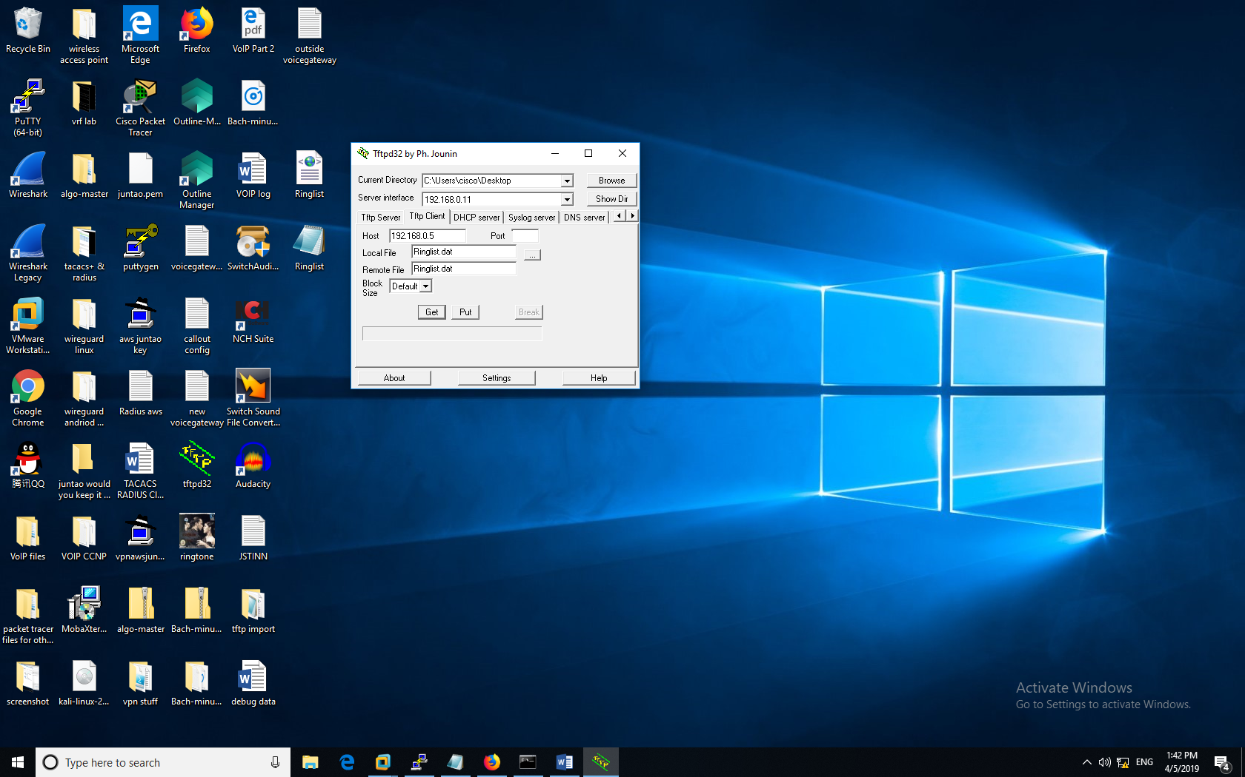

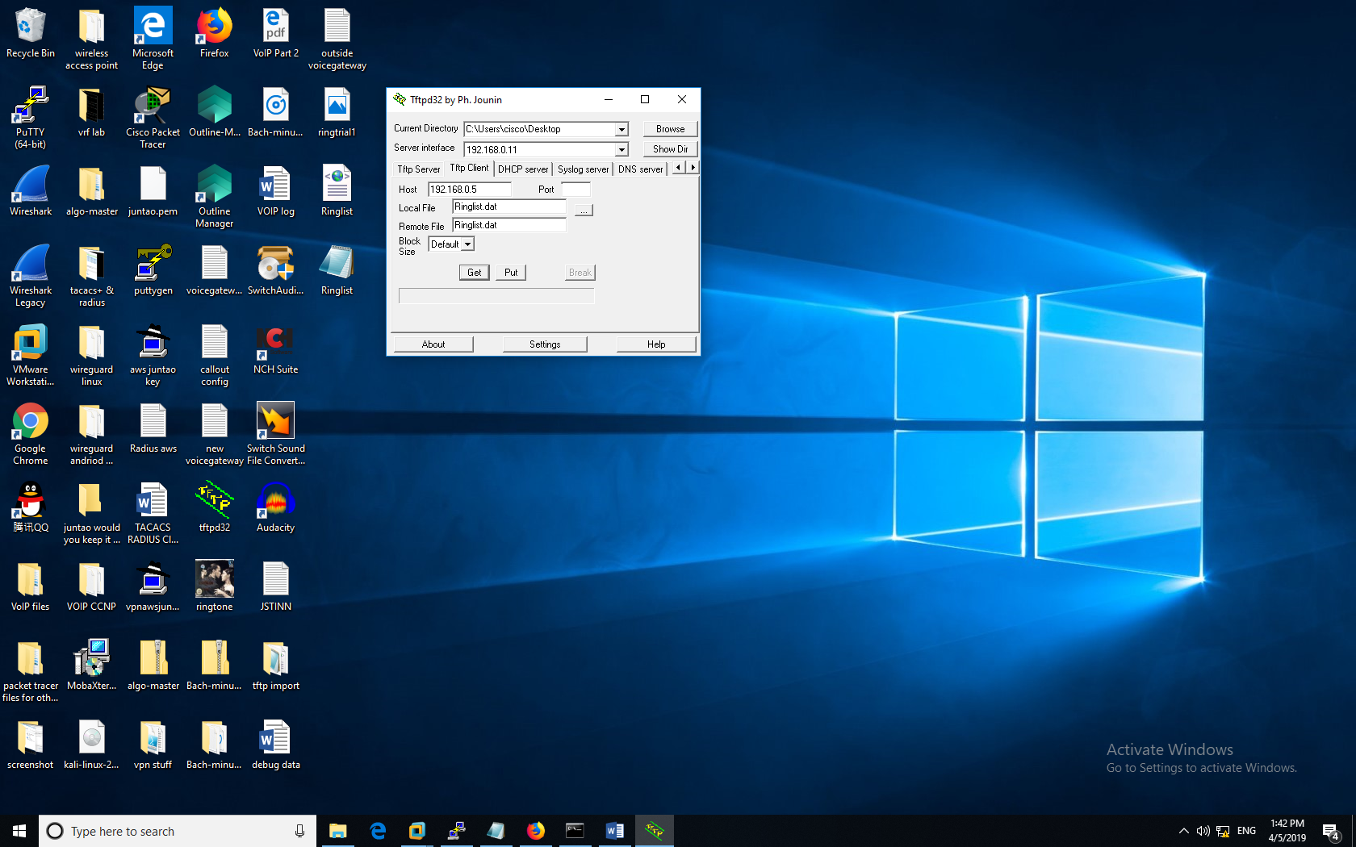

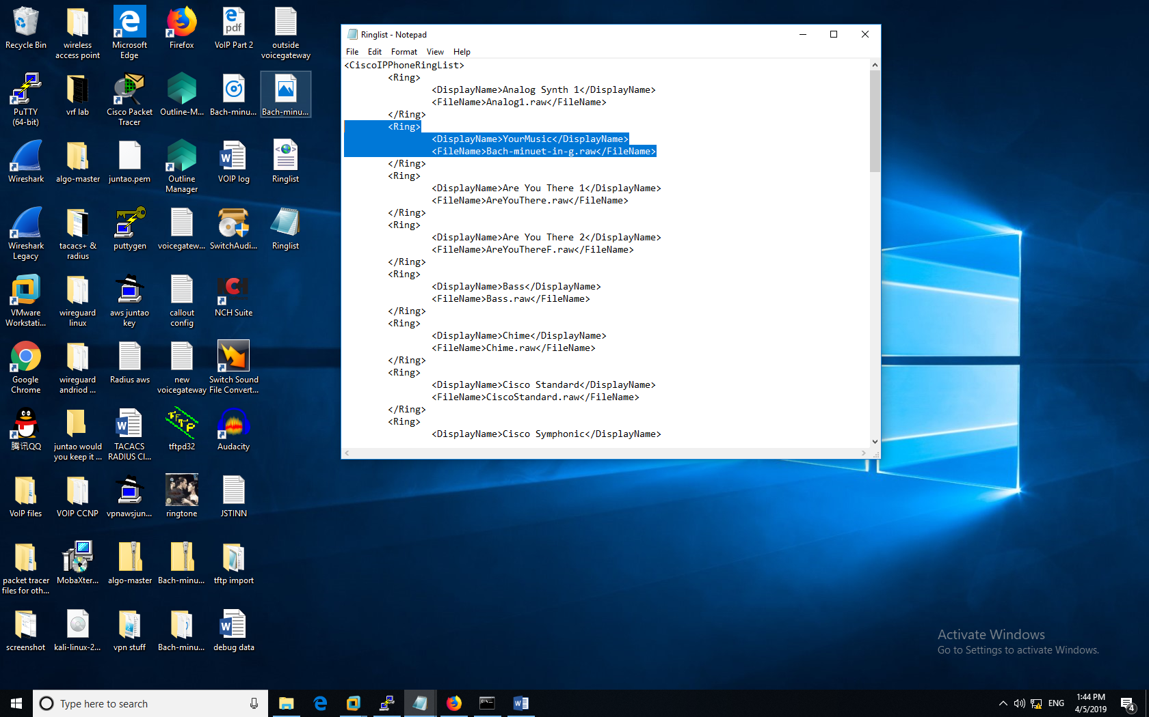

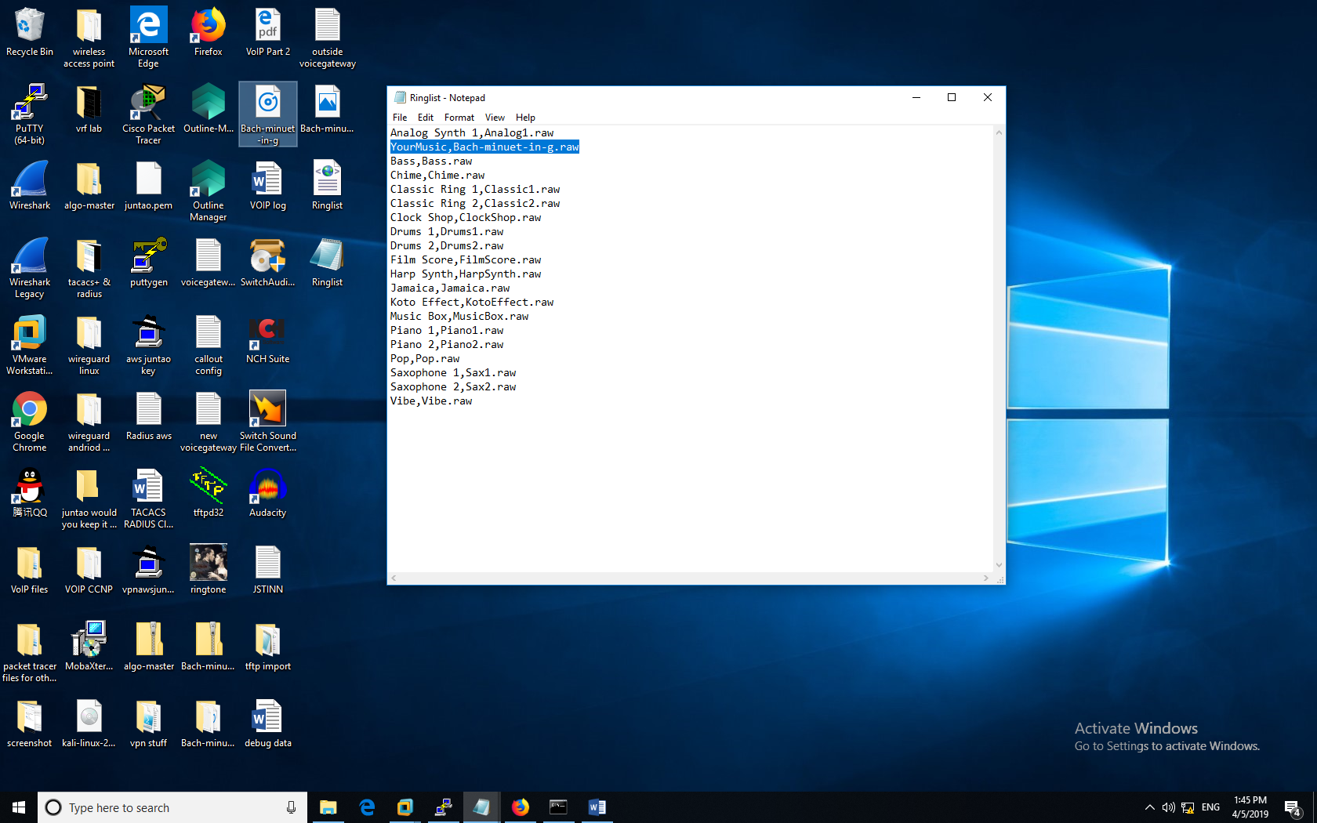

With the above configurations, I also updated the ringlist to include the new, customized file.

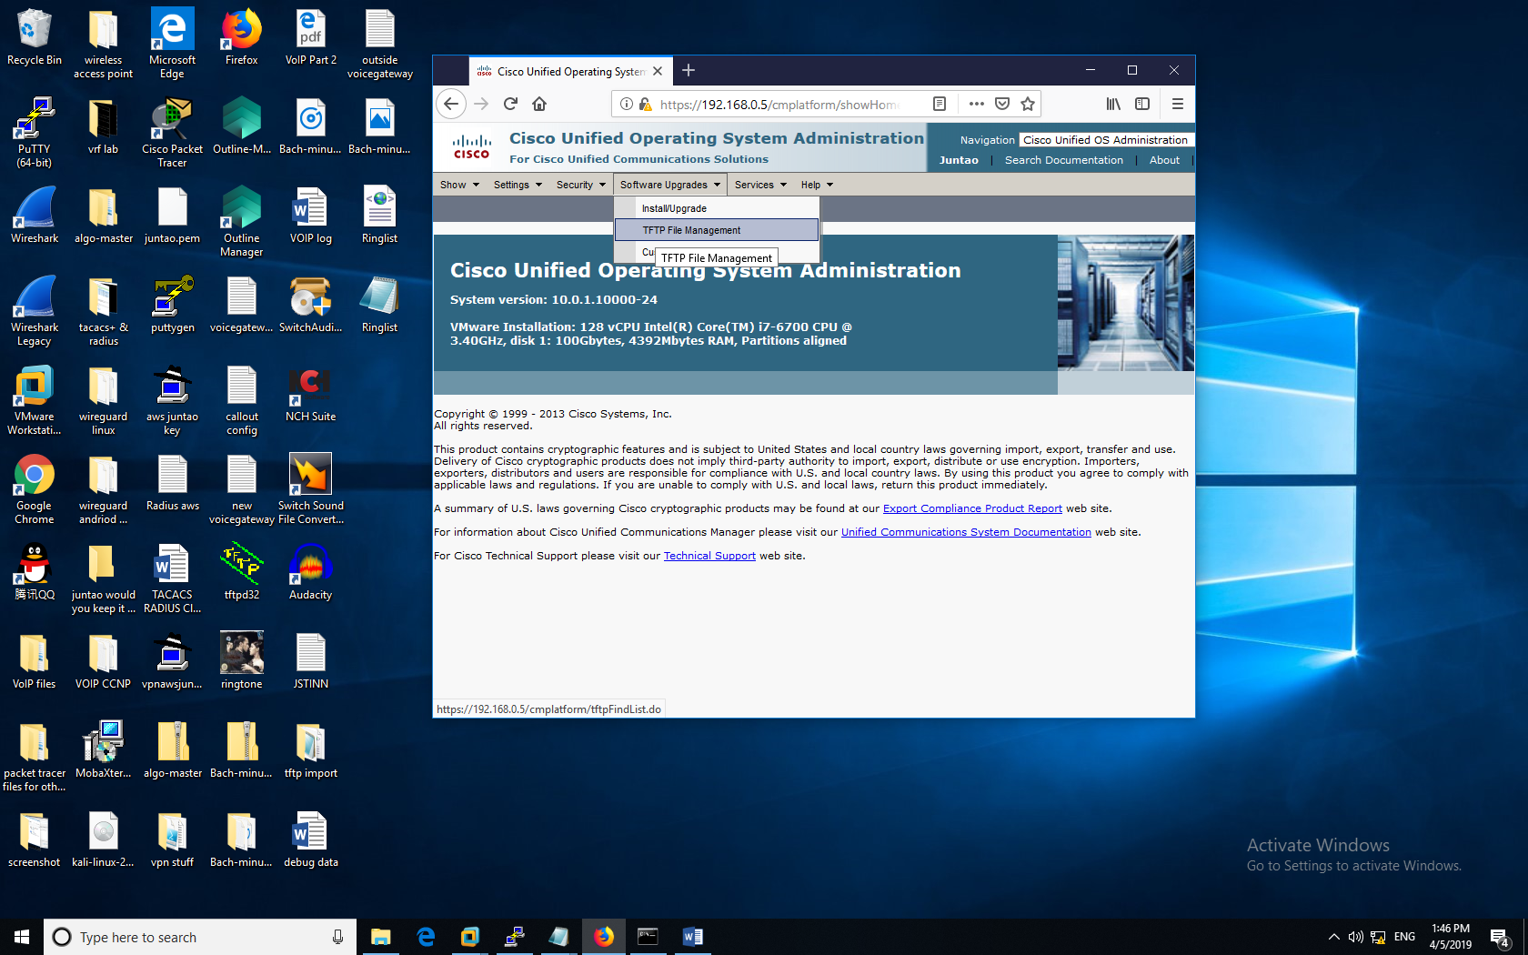

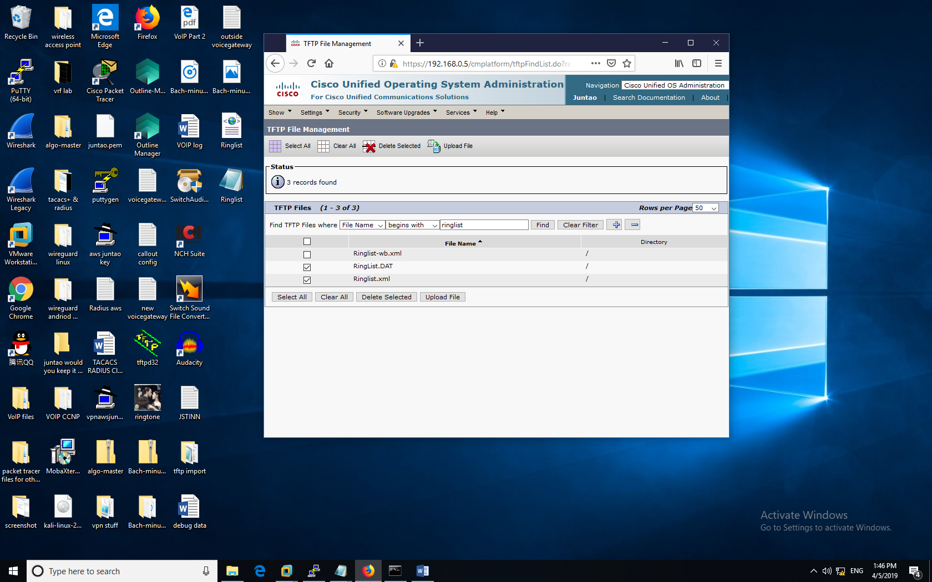

The above CUCM file manager displays the .xml settings file that is loaded onto the IP Phone.

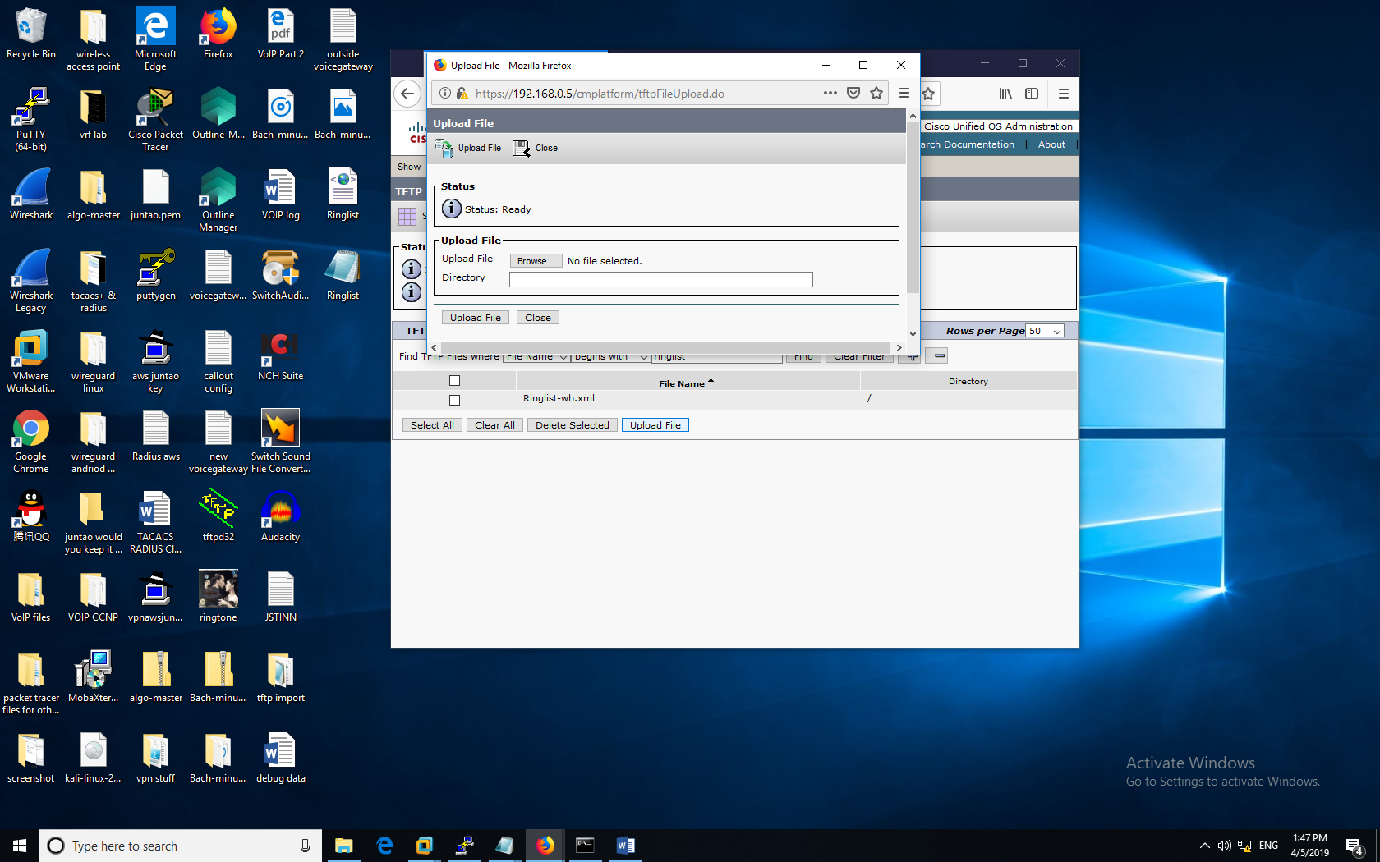

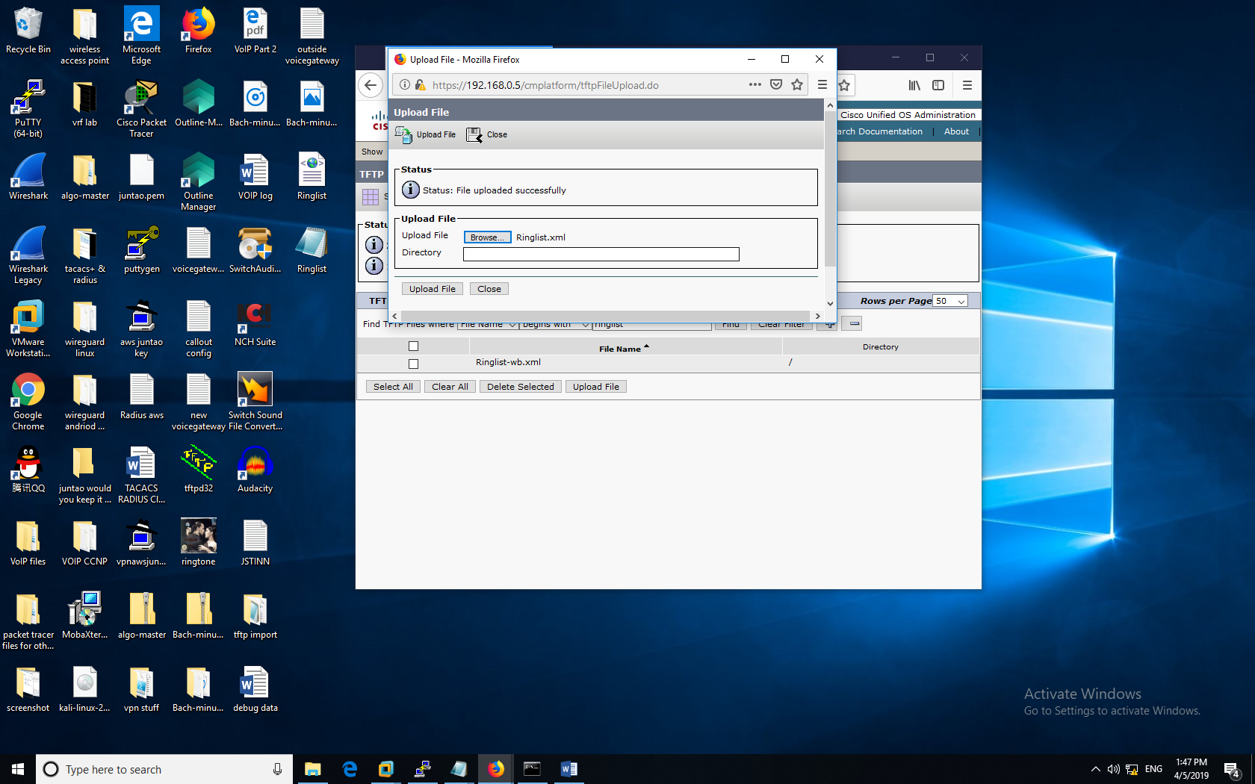

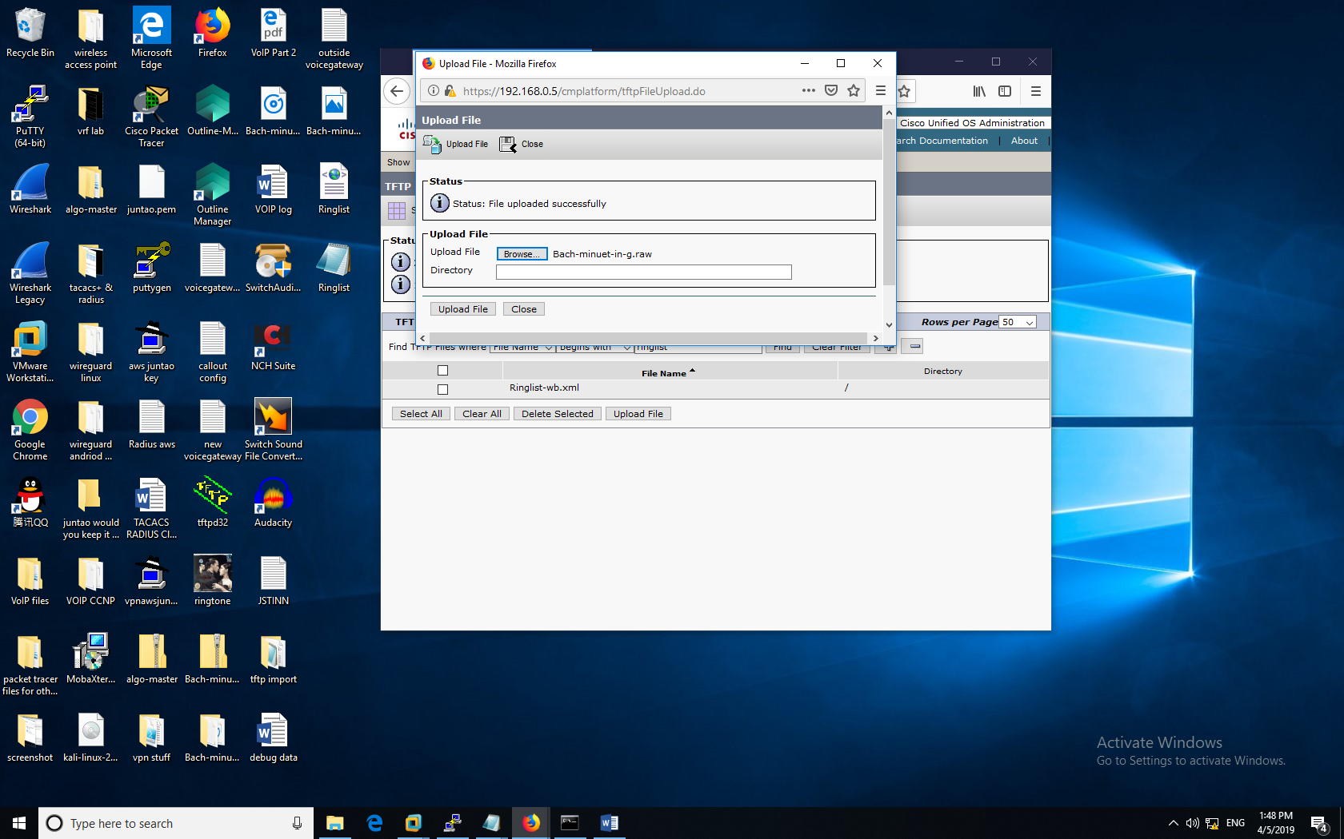

In the above screenshots, I used a web browser to upload to the CUCM directory

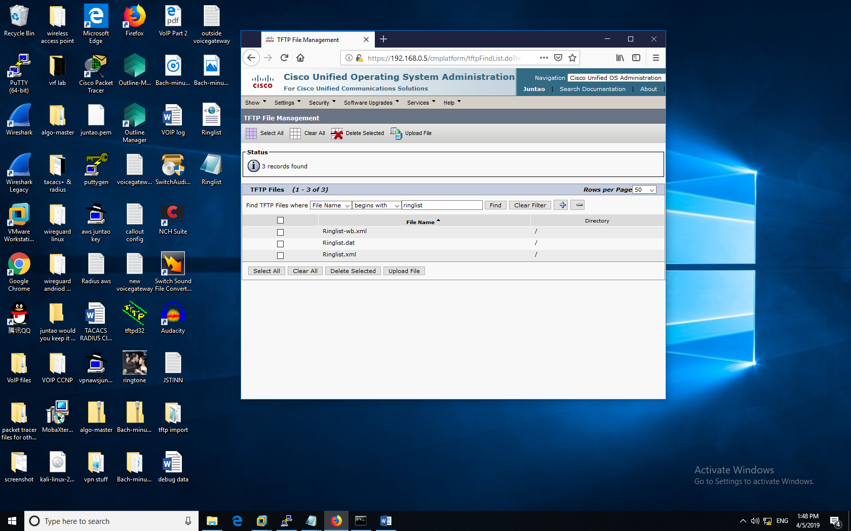

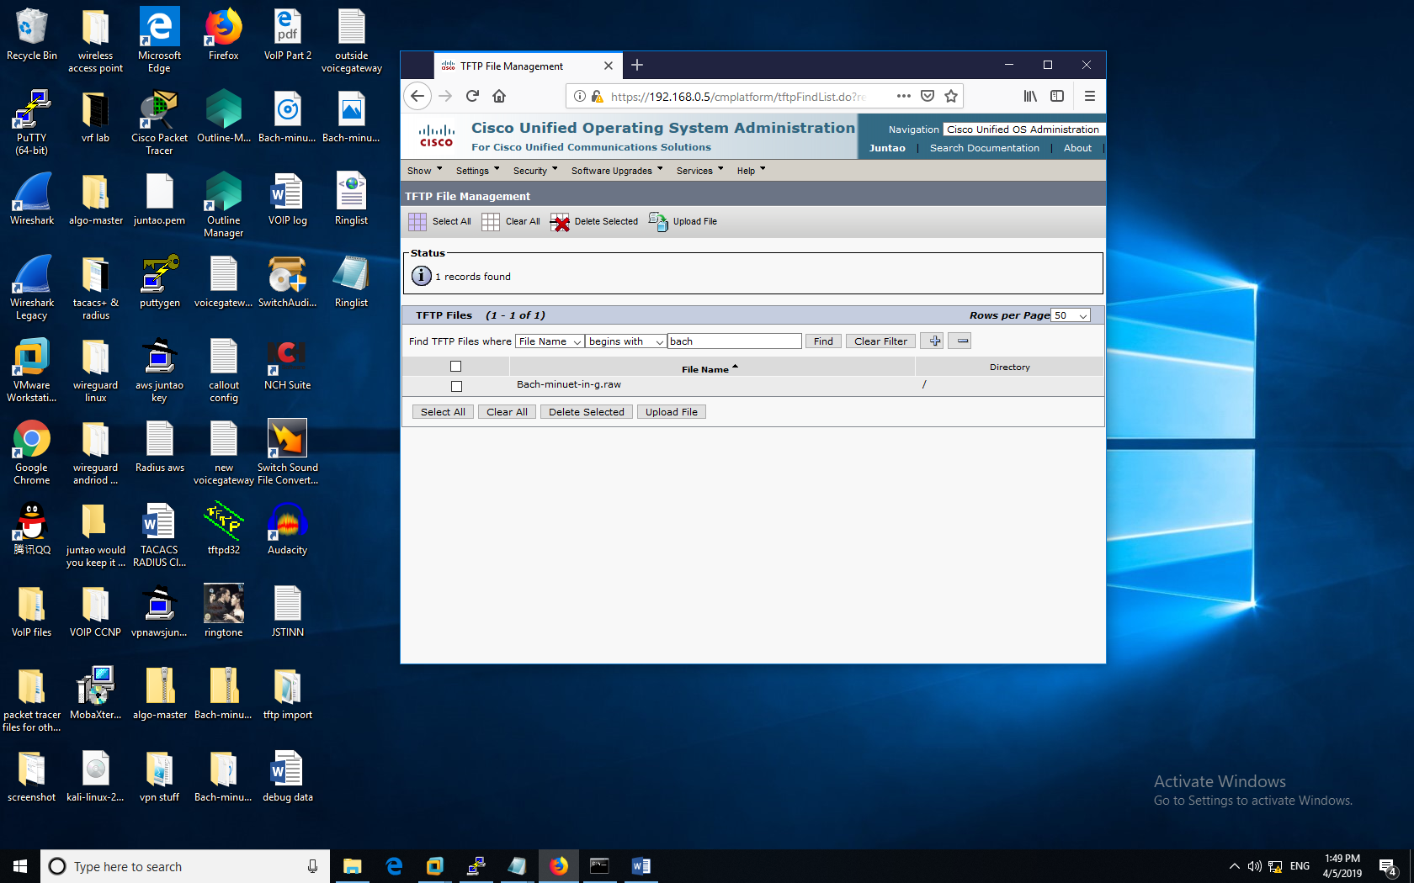

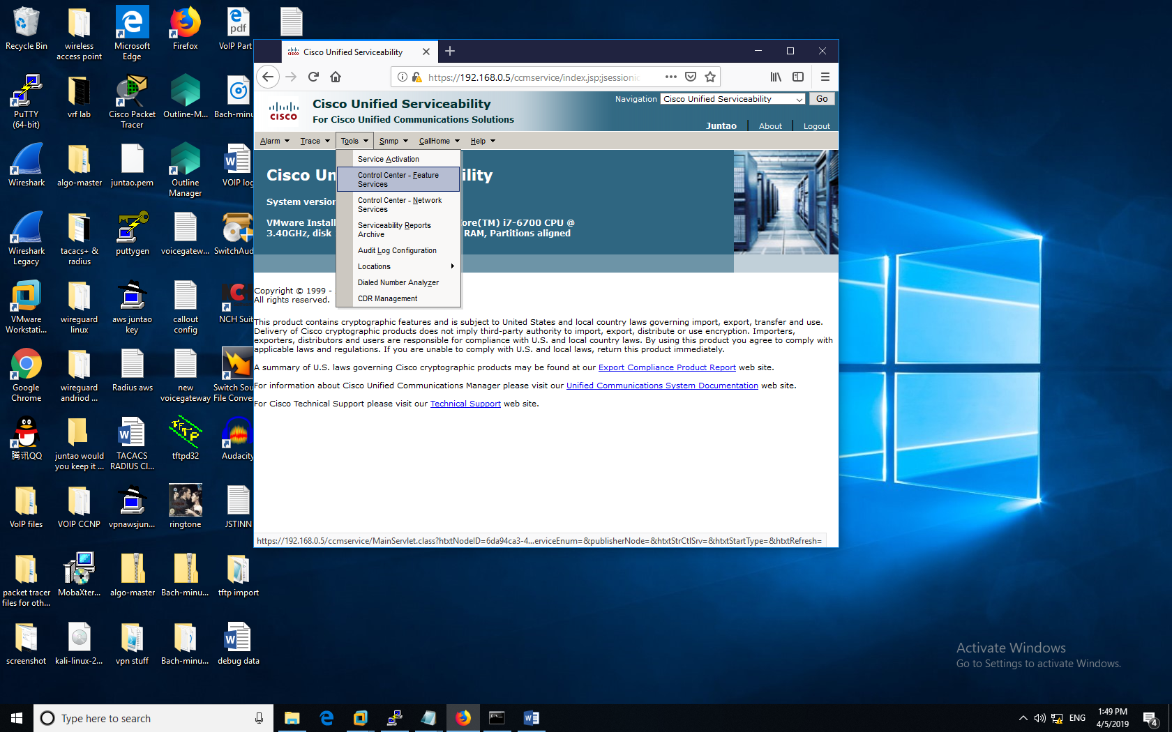

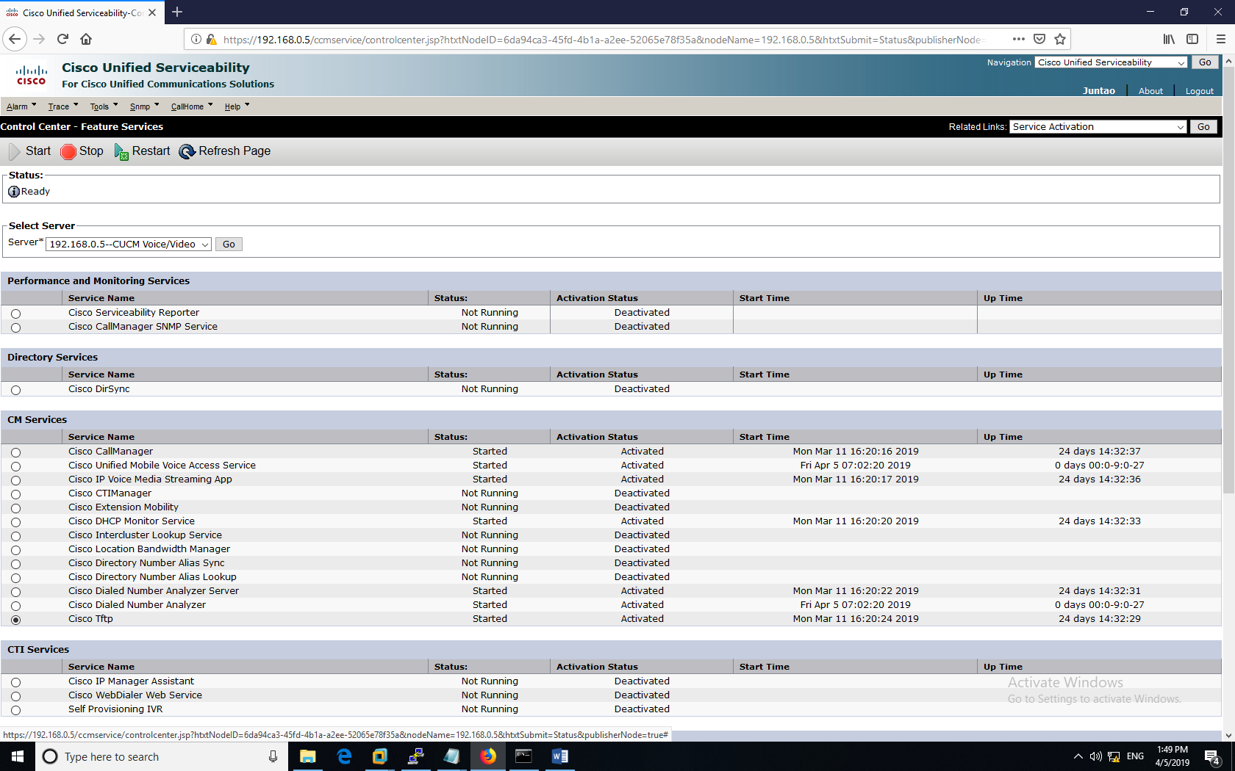

After that I headed over to the cisco unified serviceability tab and activated the Cisco Tftp module.

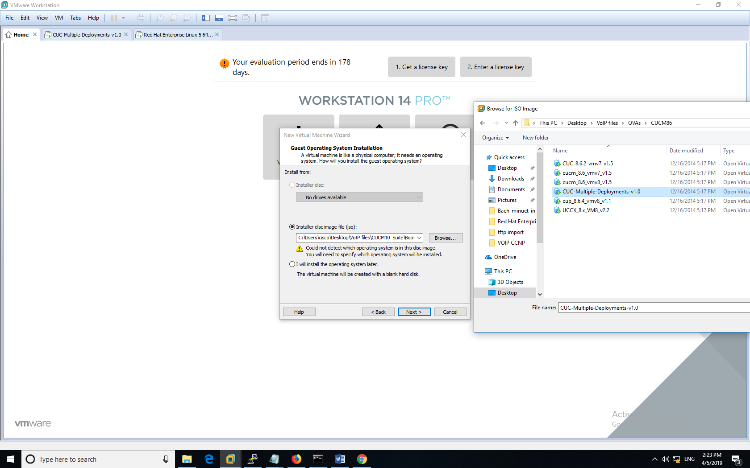

I then saved the current configuration as another virtual machine.

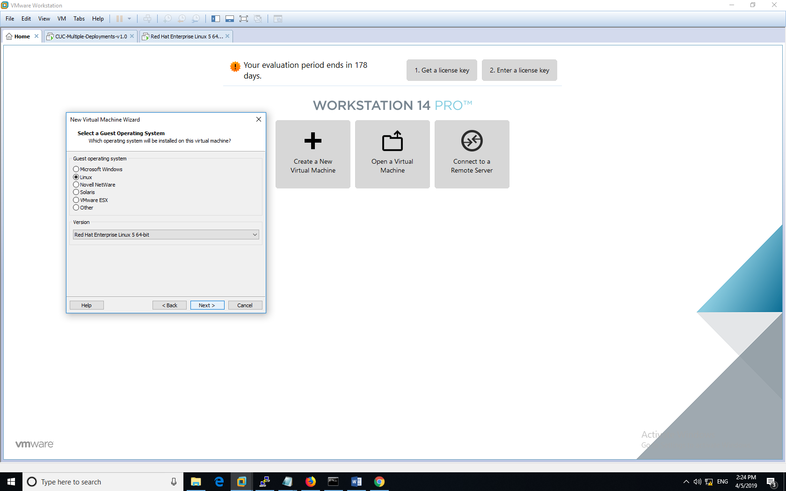

After that my lab partner and I created another virtual machine that runs linux.

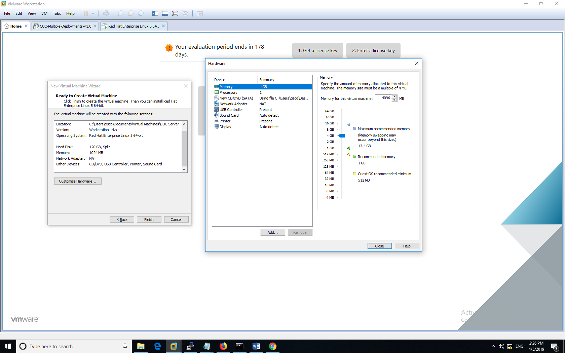

This virtual machine that I’m setting up requires the specified specifications stated above.

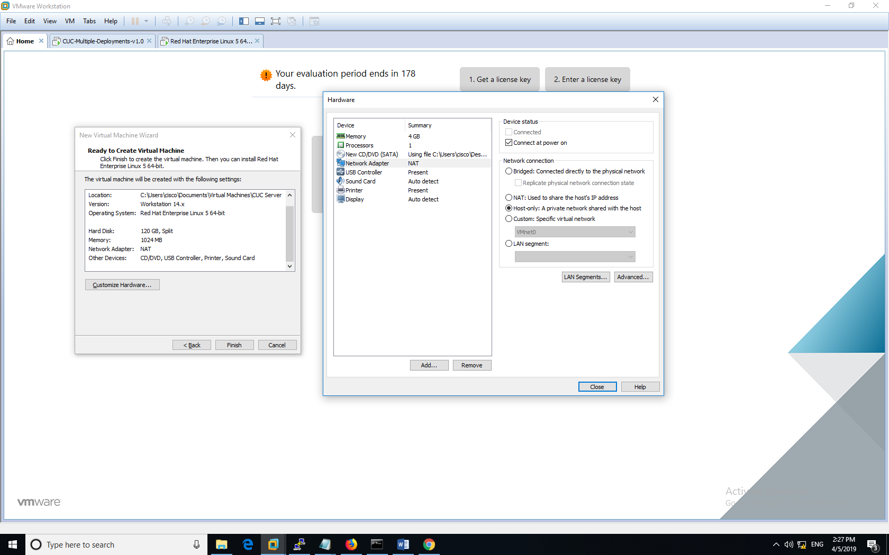

I then bridged the virtual machine to real hosts using NAT private network shared with the host.

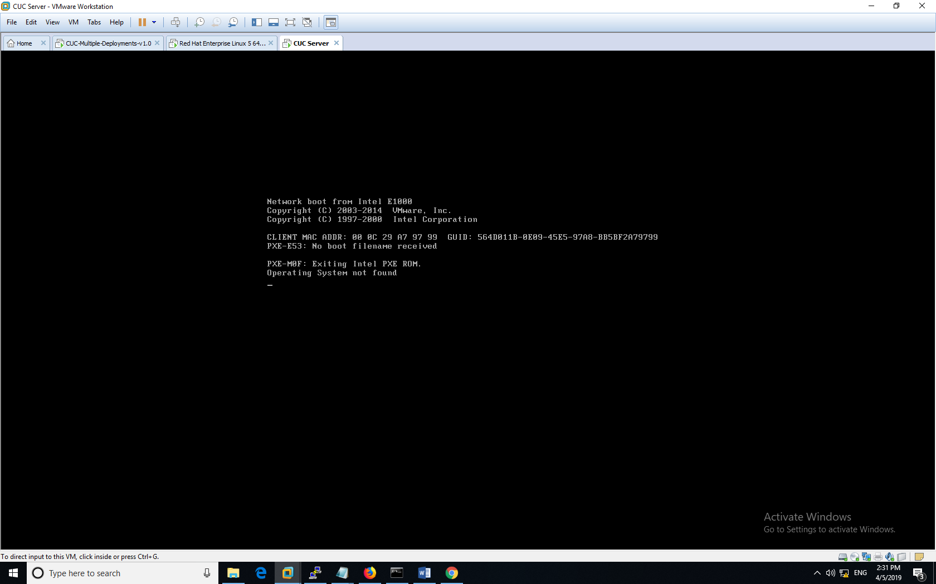

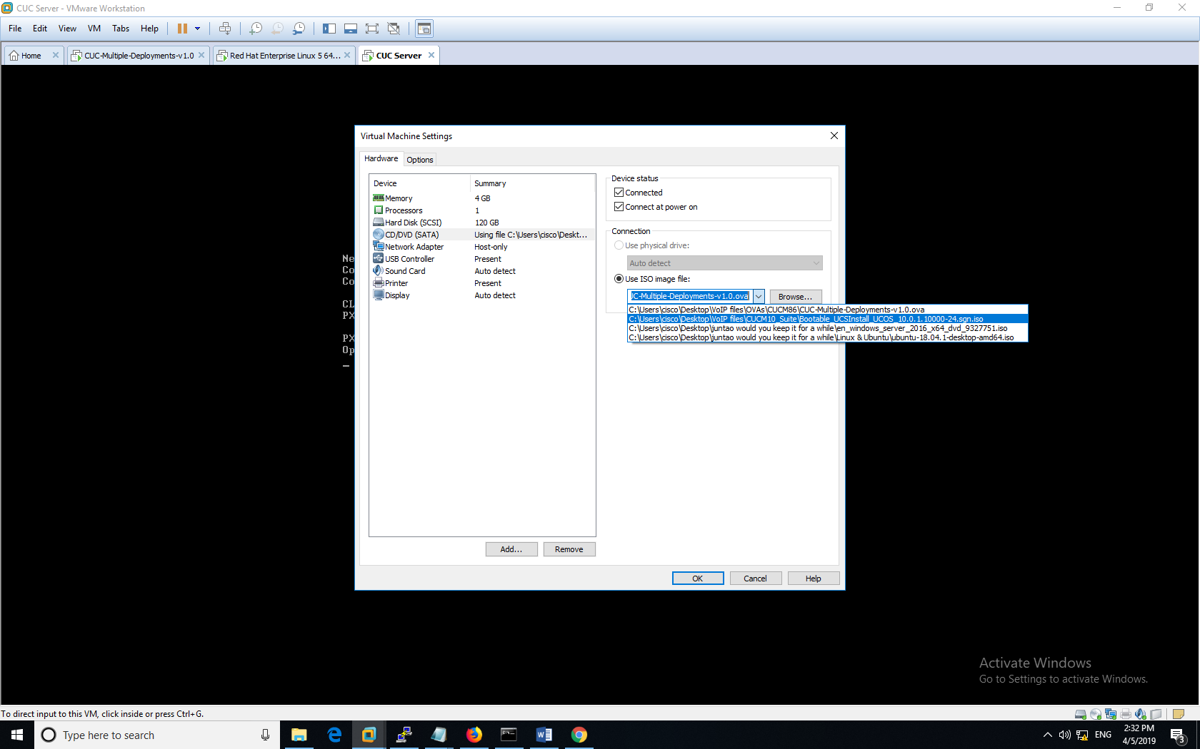

We loaded this specific image file into the blank virtual machine.

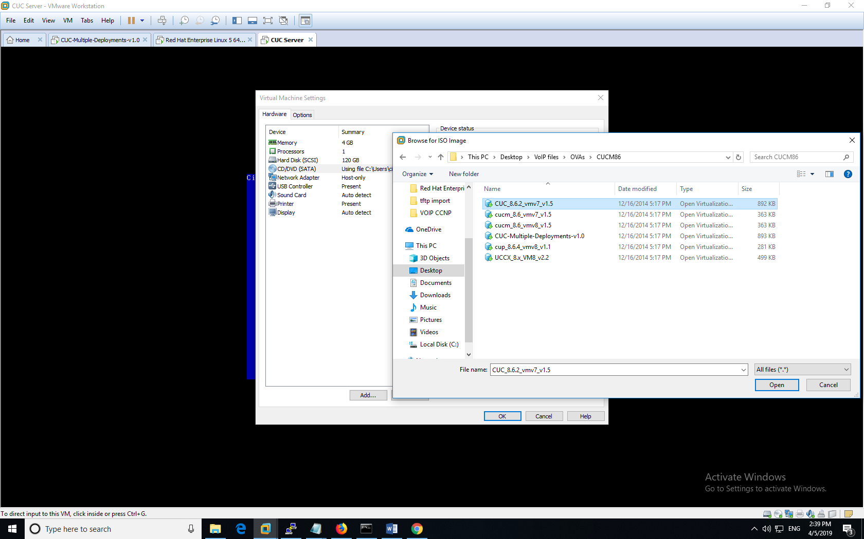

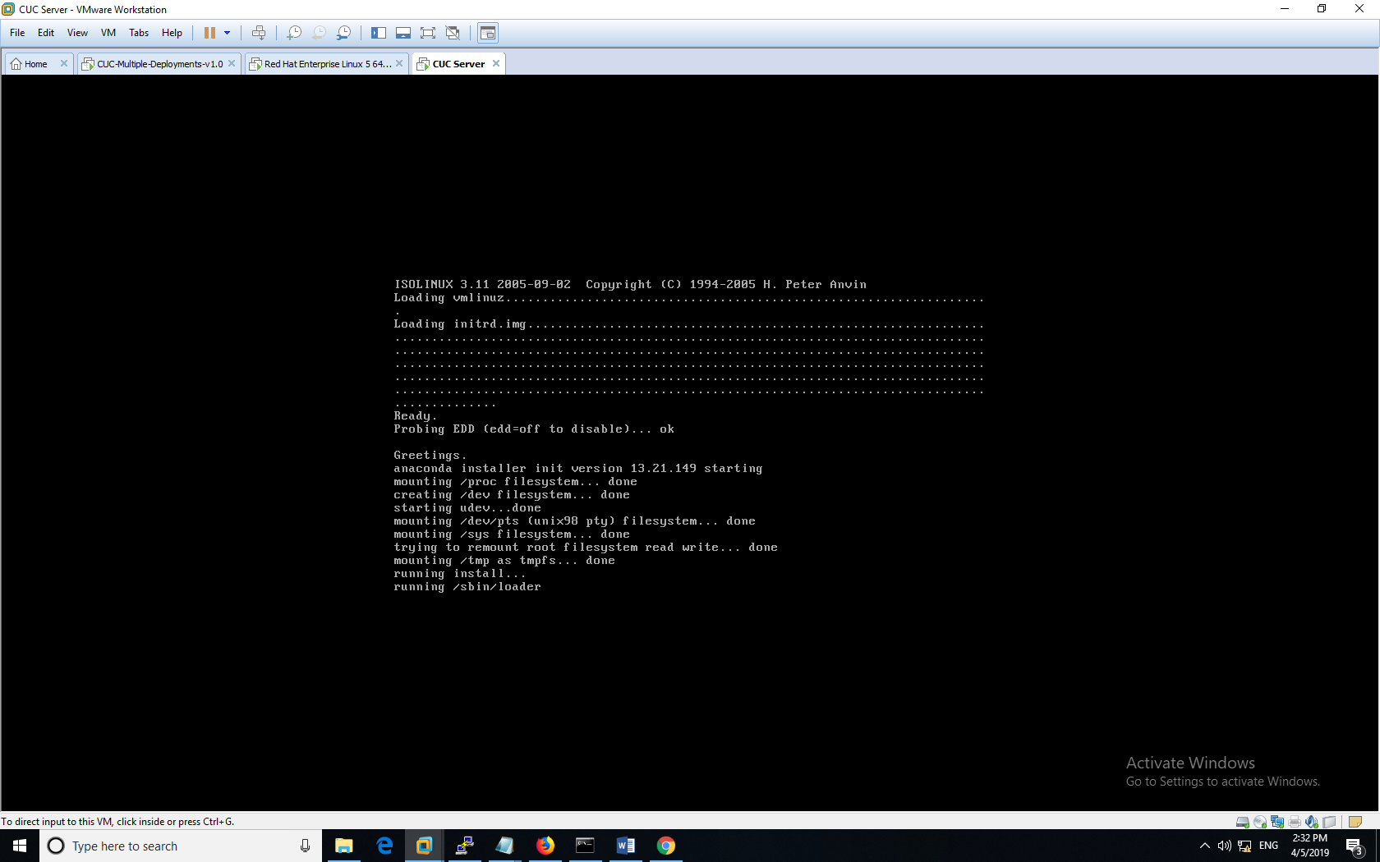

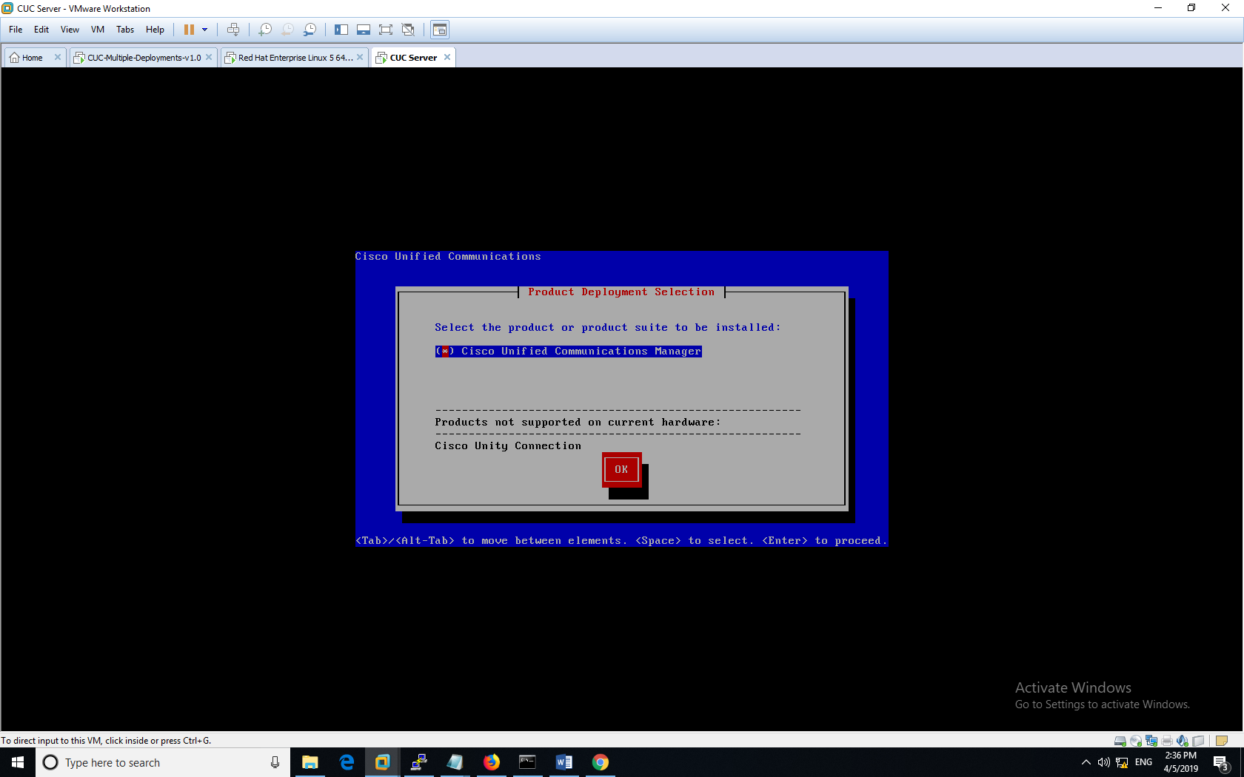

Now with the Manager OS fully loaded, we will store the created virtual machine as an image file.

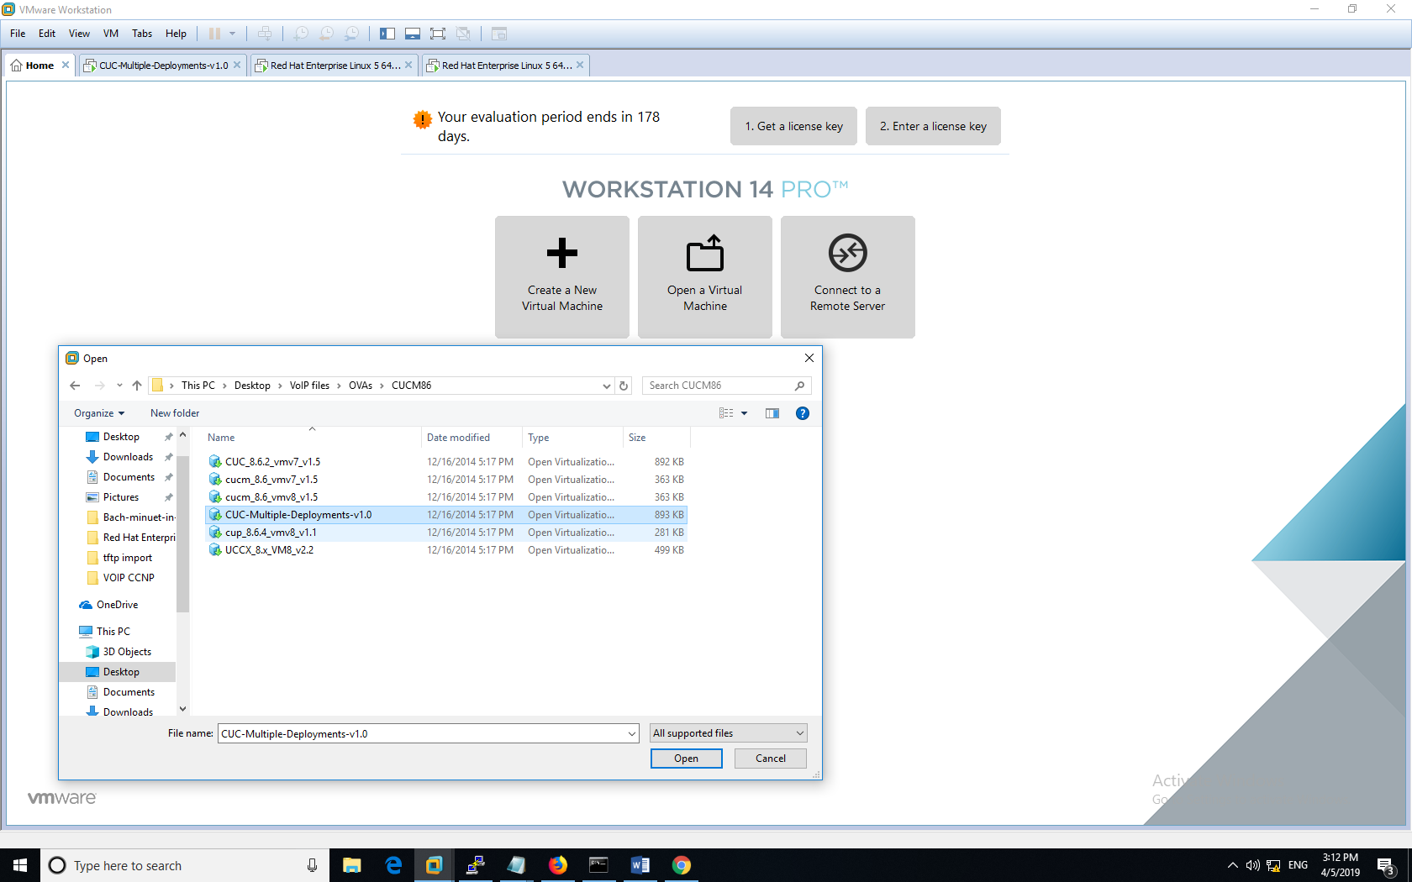

We named our image file ‘CUC’ server in this lab.

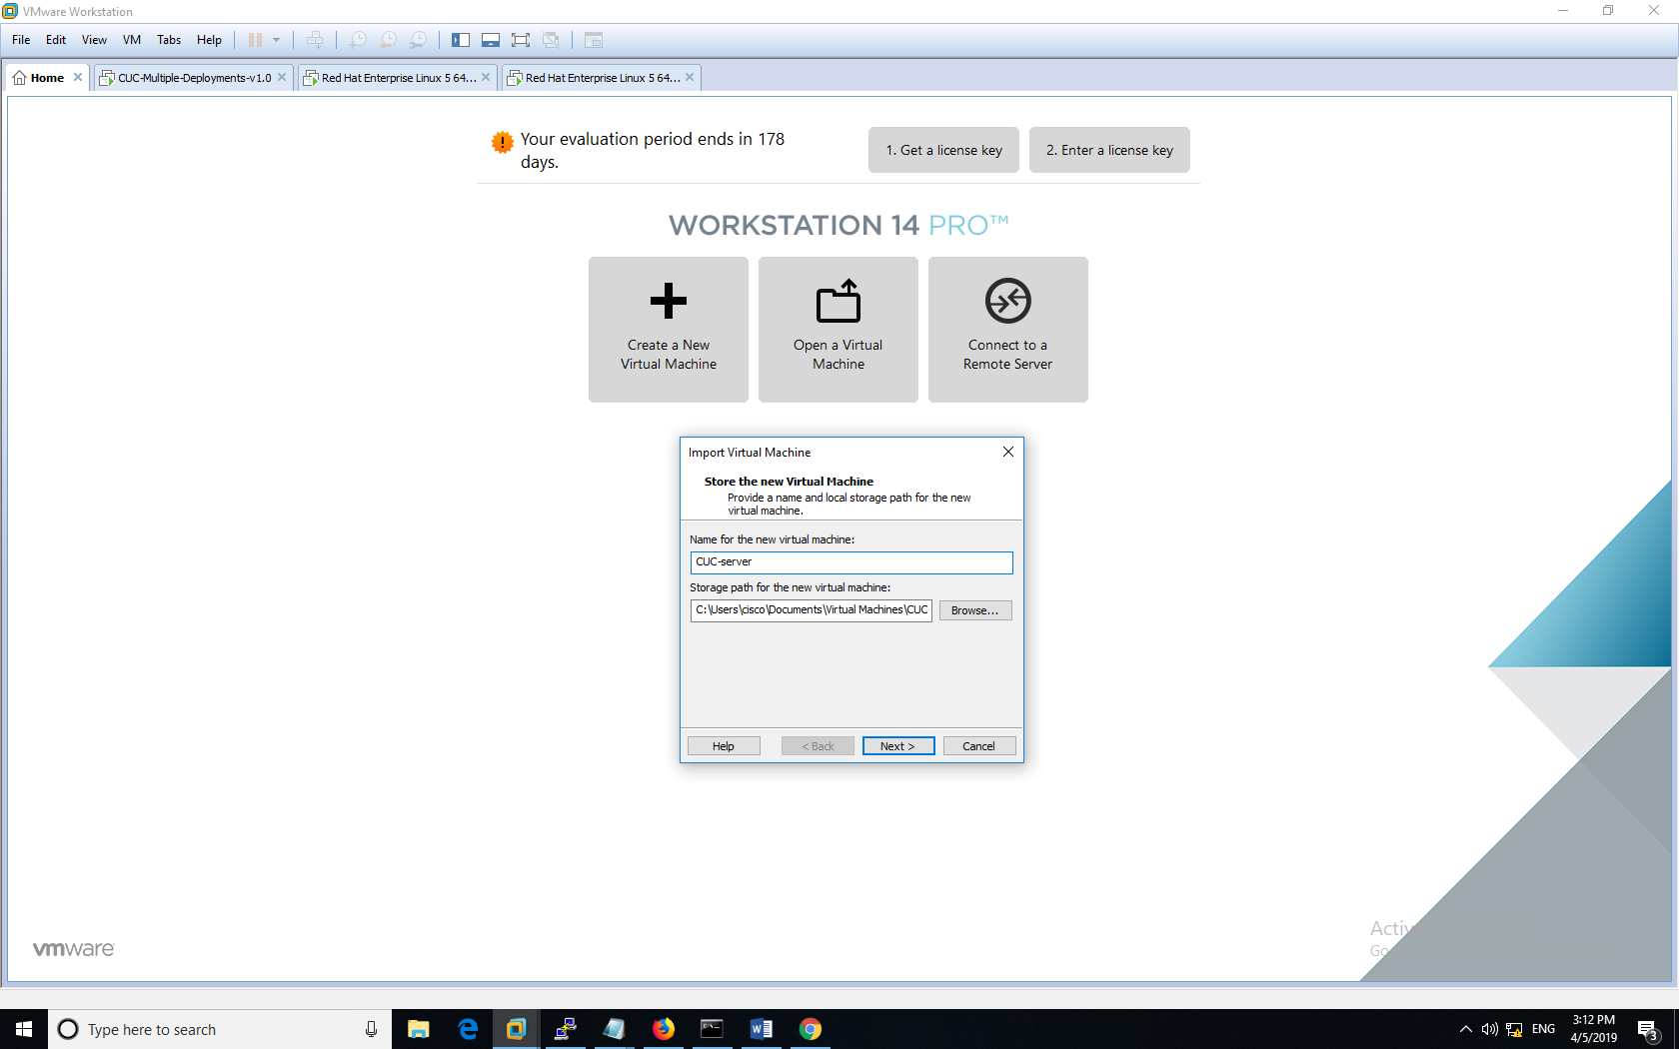

In this next section here, we are in the process of ‘importing the virtual machine’ from the image file we just created.

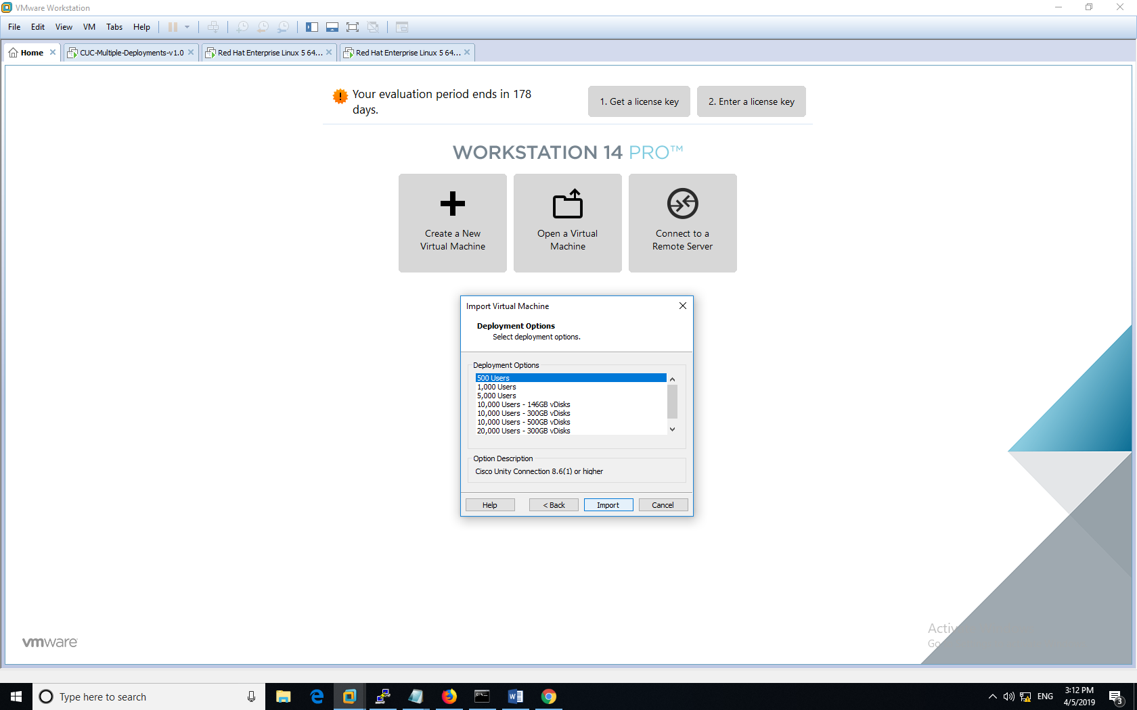

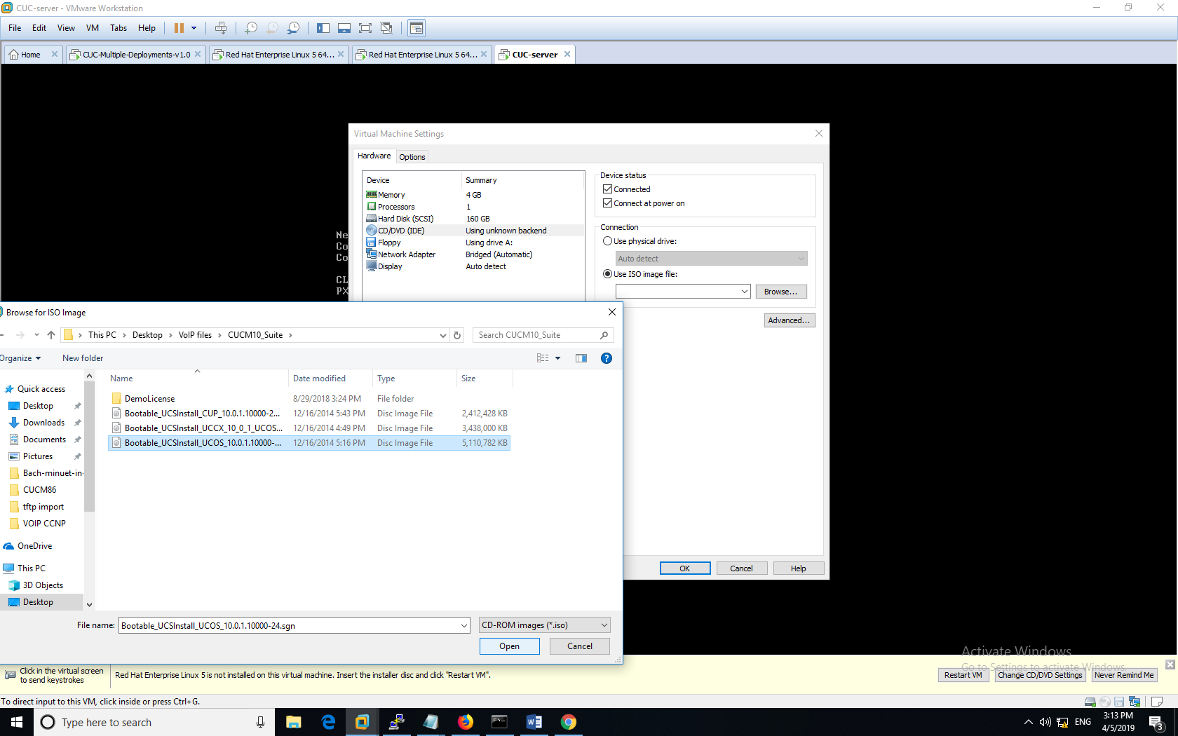

The image file has loaded, and we are now selecting the CUCM.

\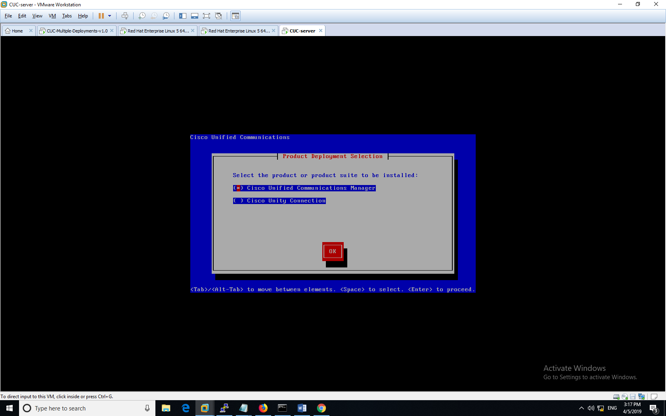

The next screen shows the various packages that have been activated/deactivated.

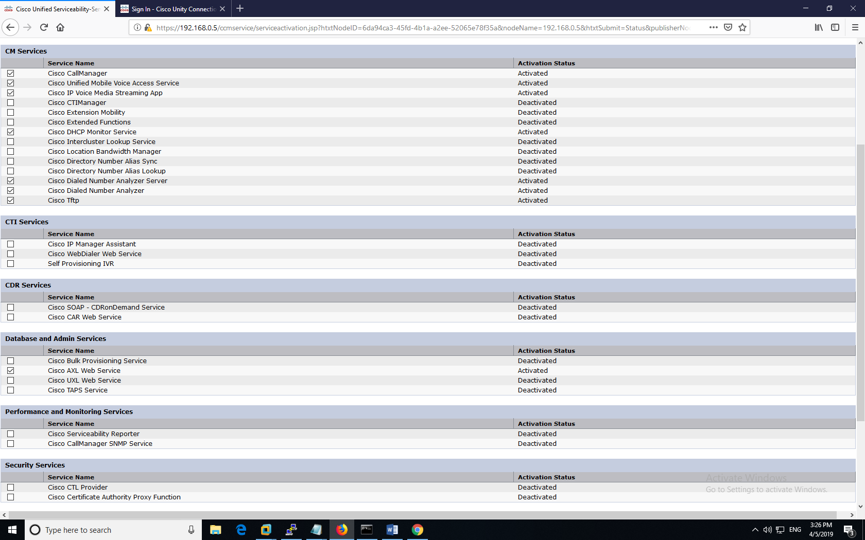

For the next part, we navigated over to the Advanced Features tab and began to configure the voice mail profile.

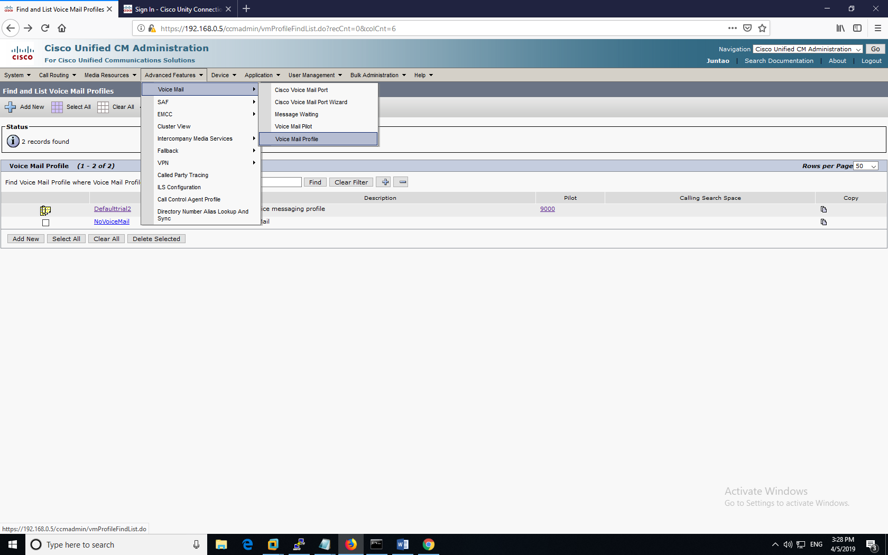

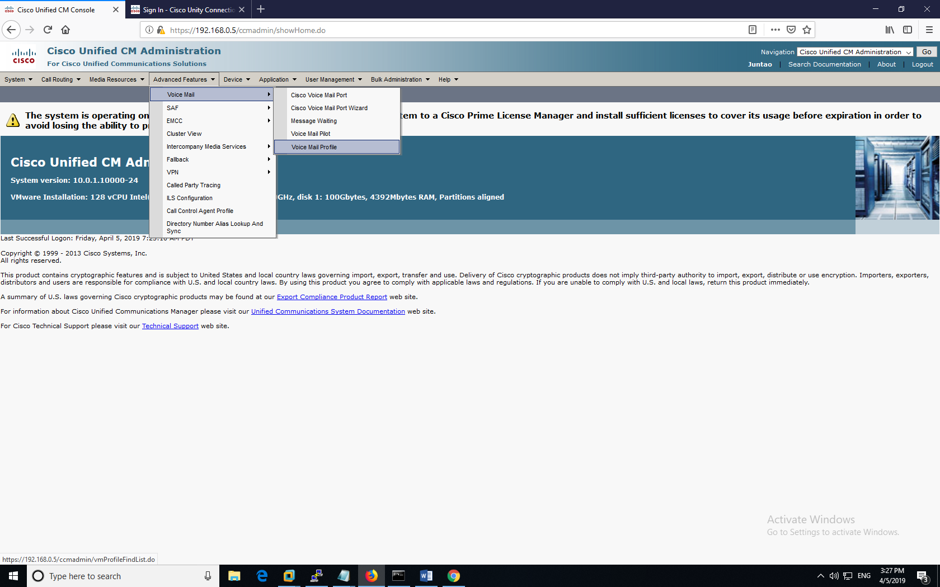

For this lab, we named our Voice mail profile “Defaultrial2”, and we hooked it up to 2 cisco end devices. The following screenshots display how we configured the voice mail pilot within this module.

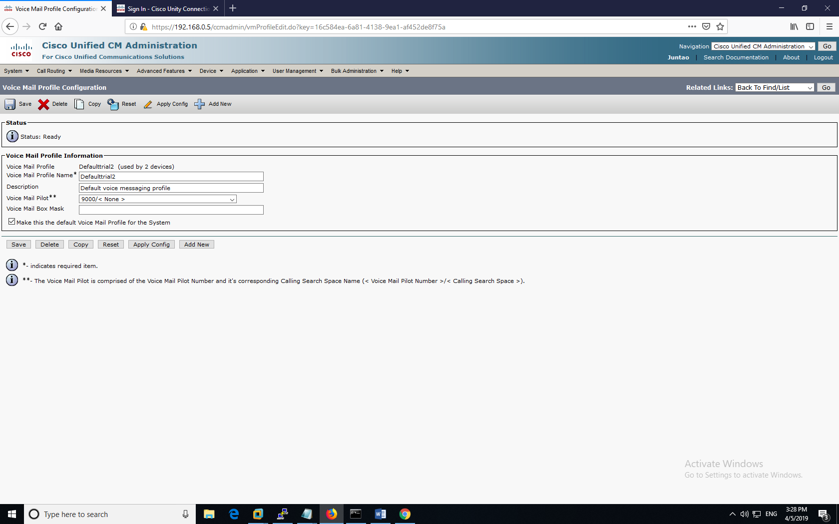

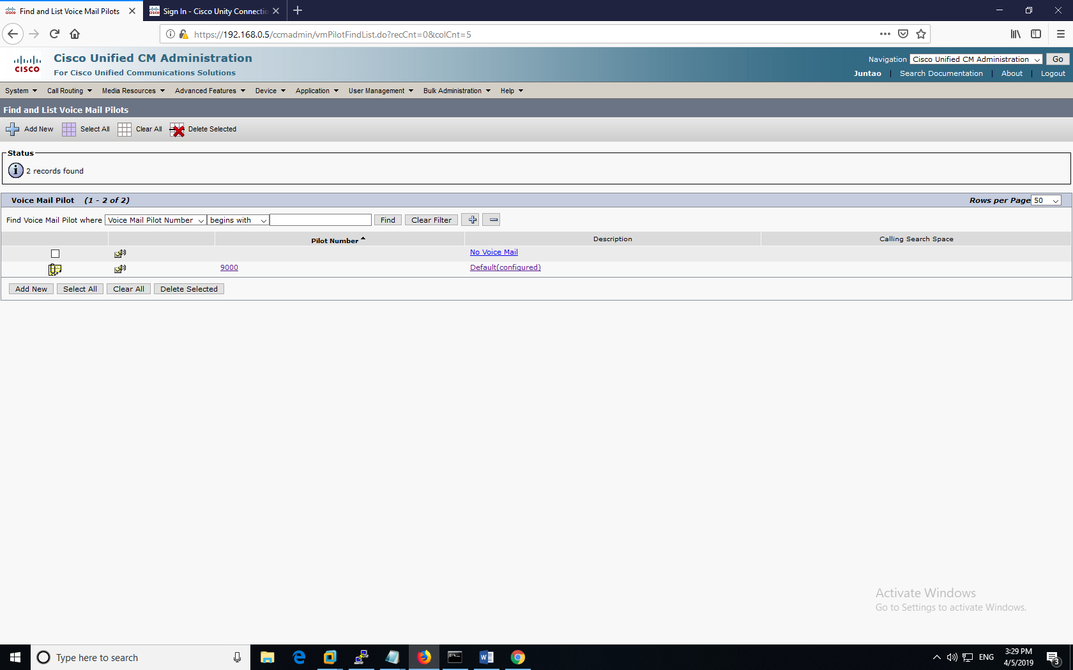

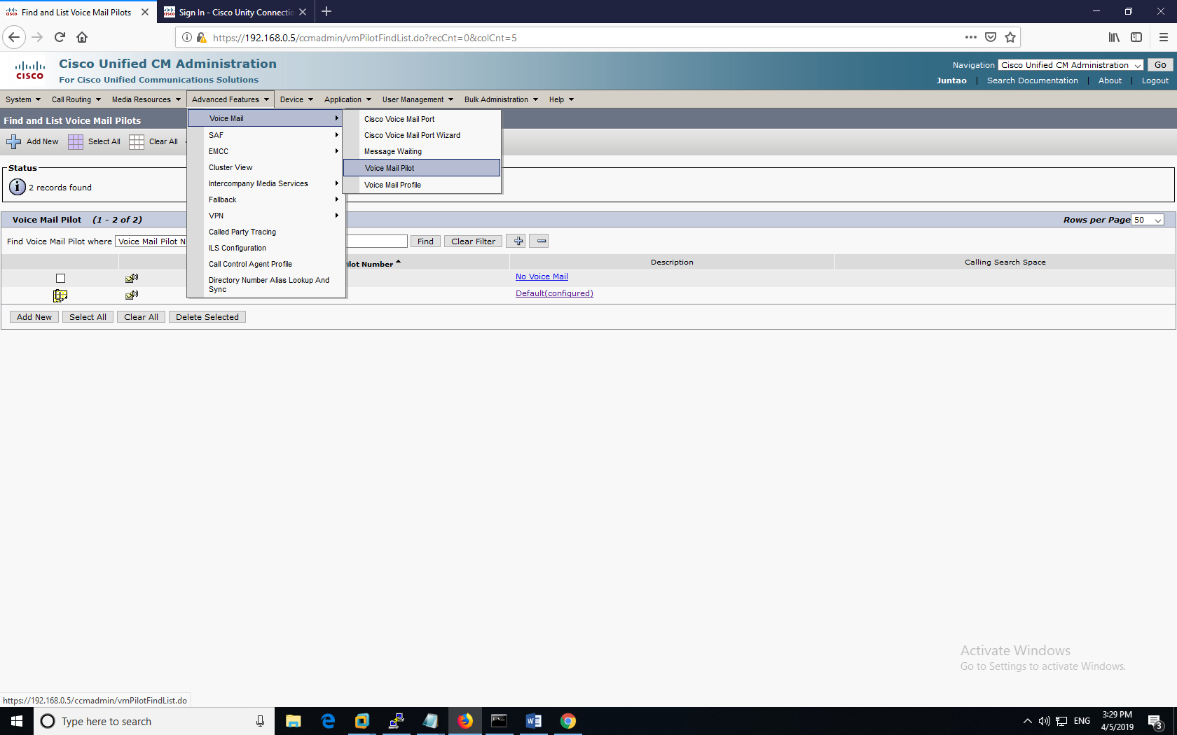

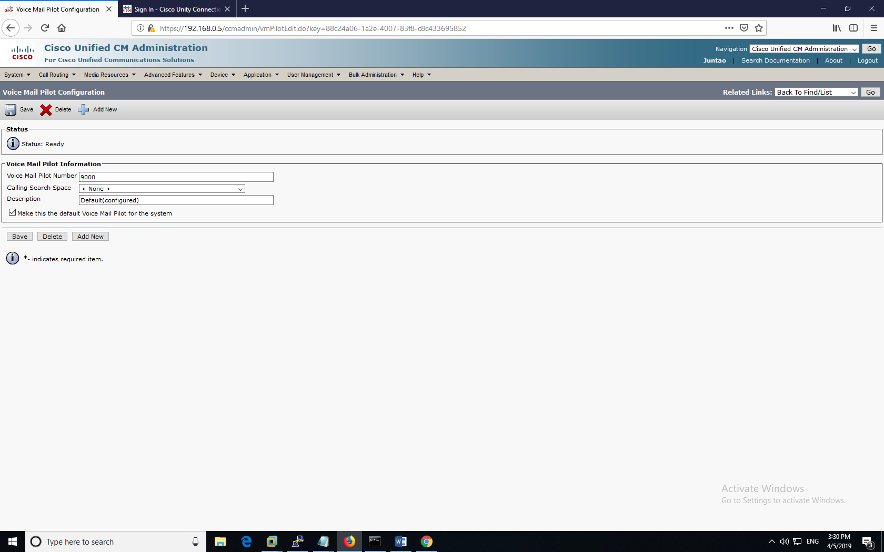

After that has been completed, the different colored icons represent the status of the end user devices. We gave them custom directory numbers of “0000” and “0001”.

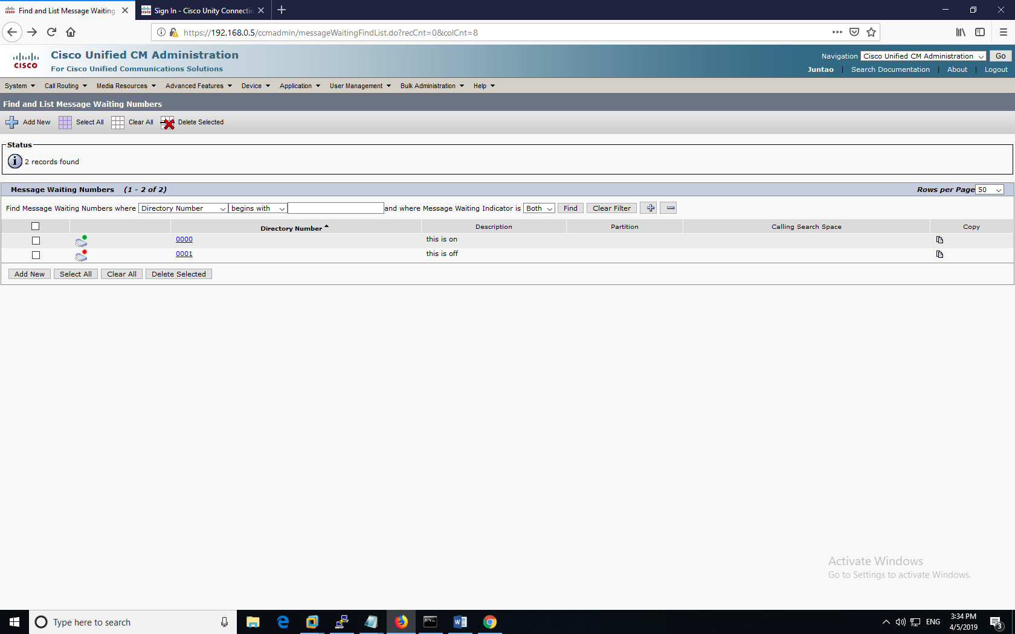

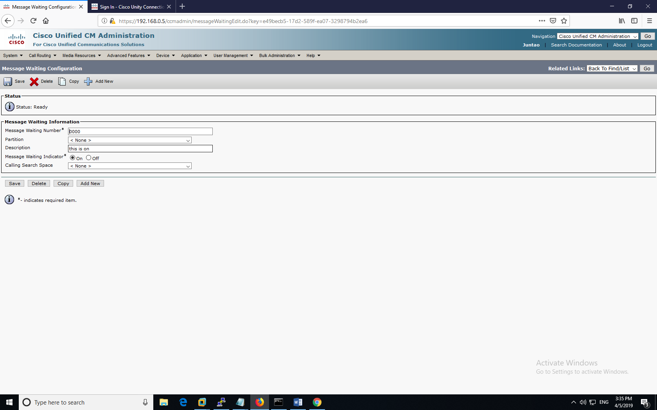

The following screenshots display our process of using ‘VMportwizard’ on the CUC manager.

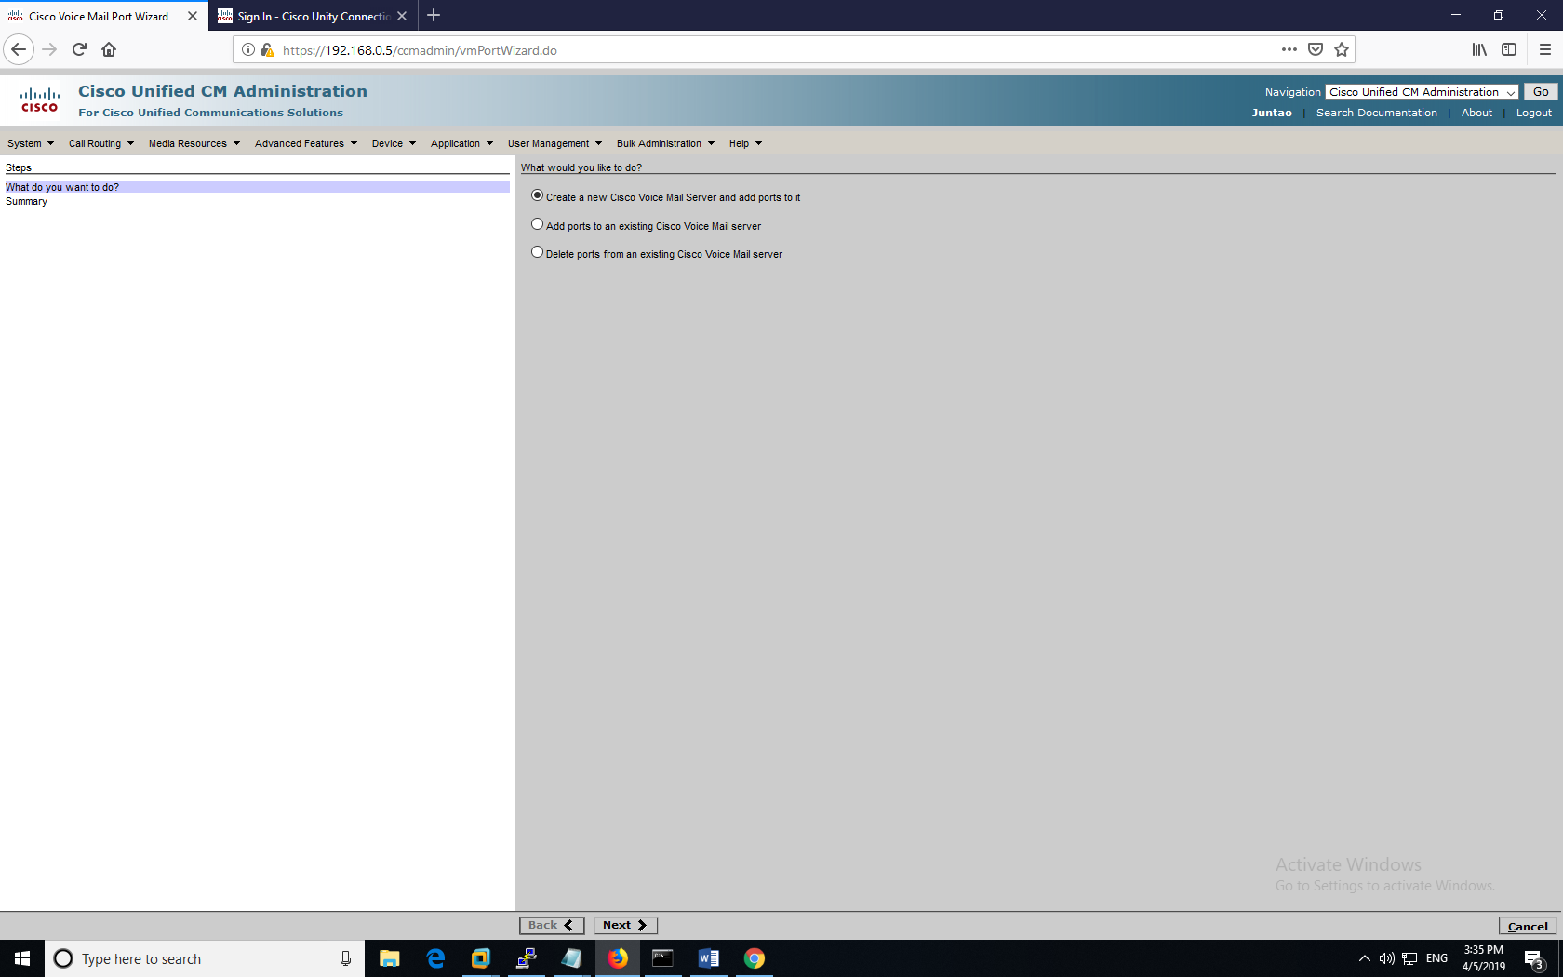

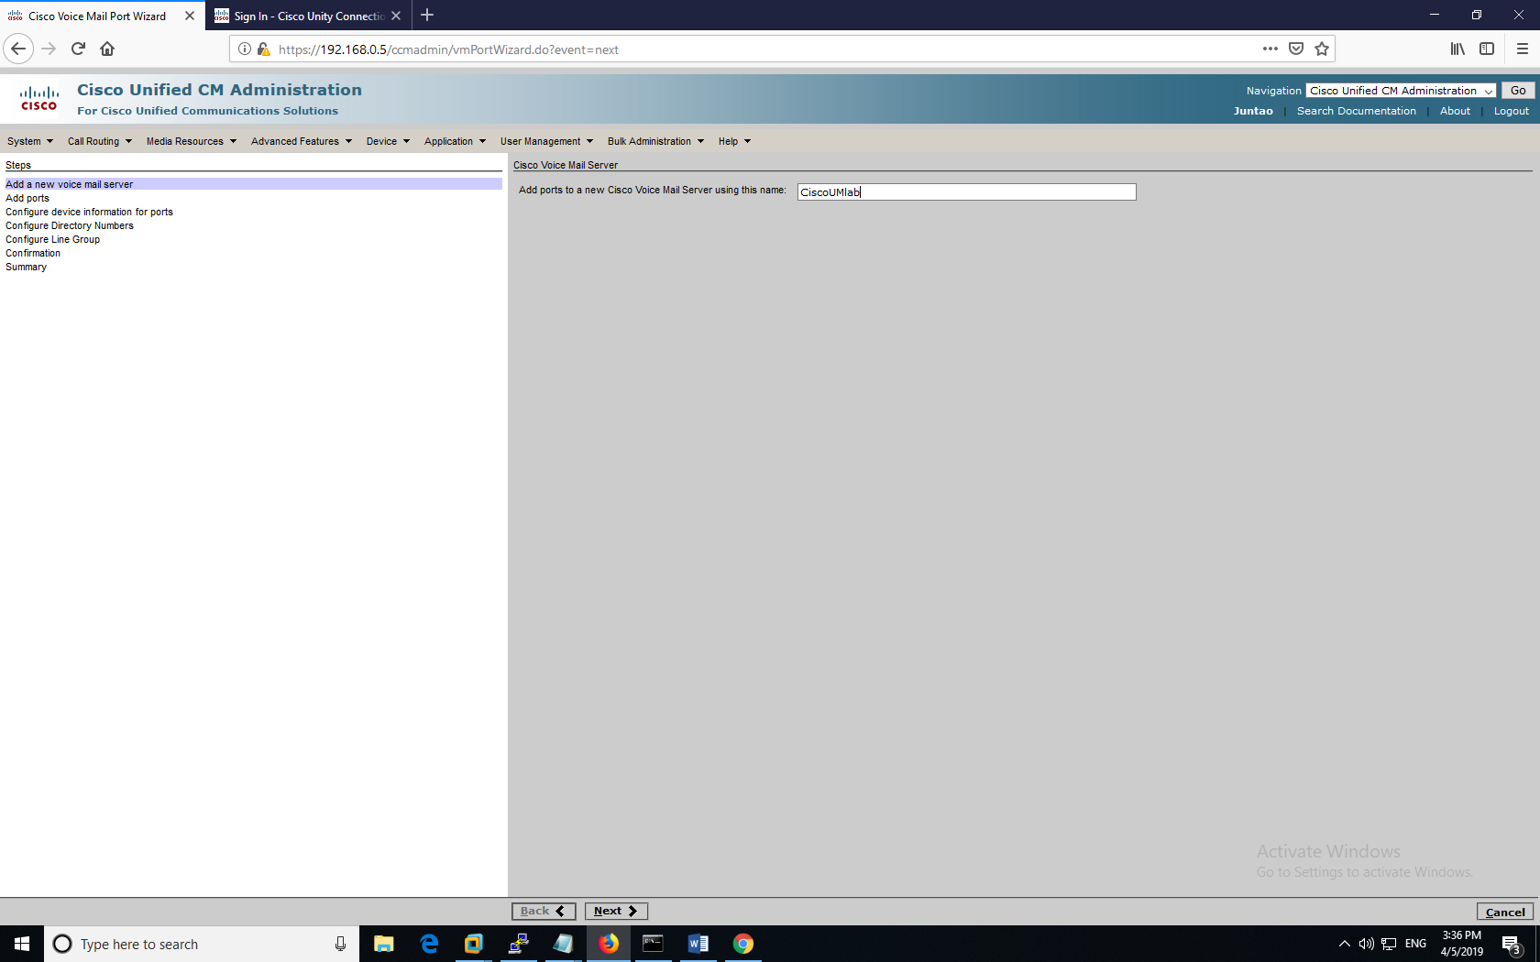

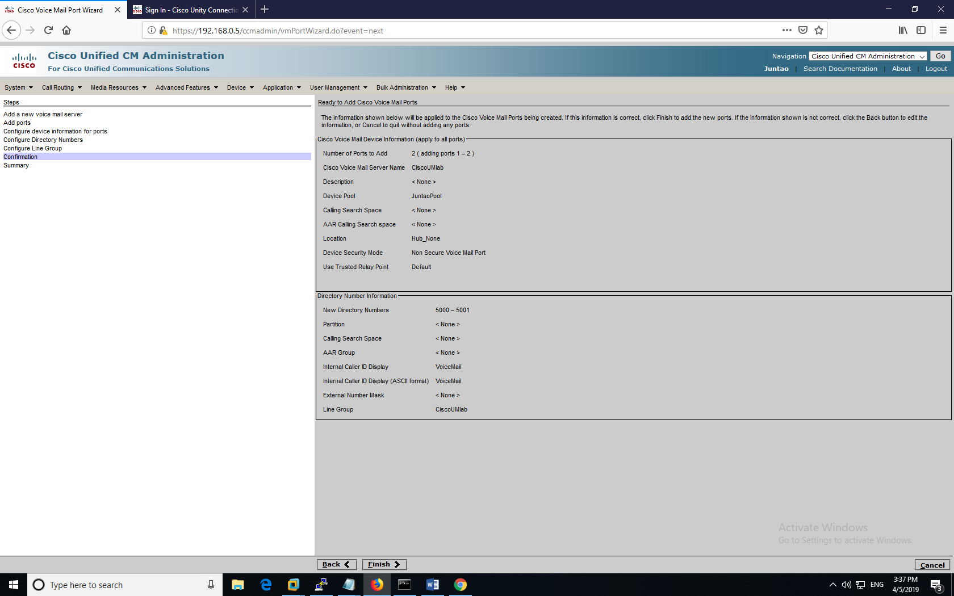

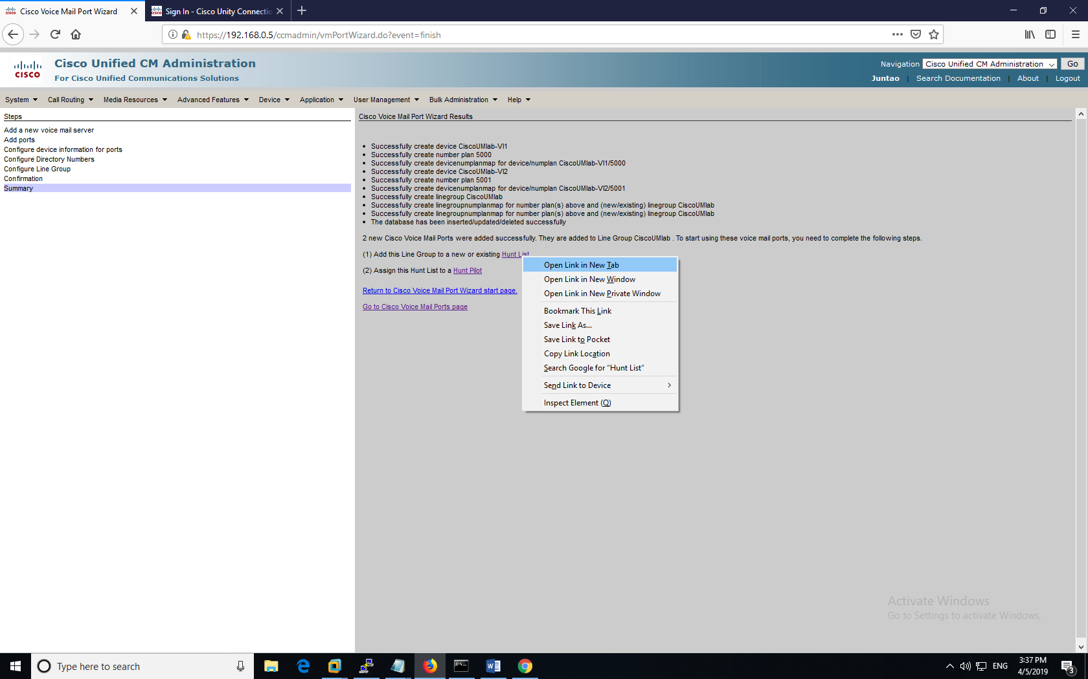

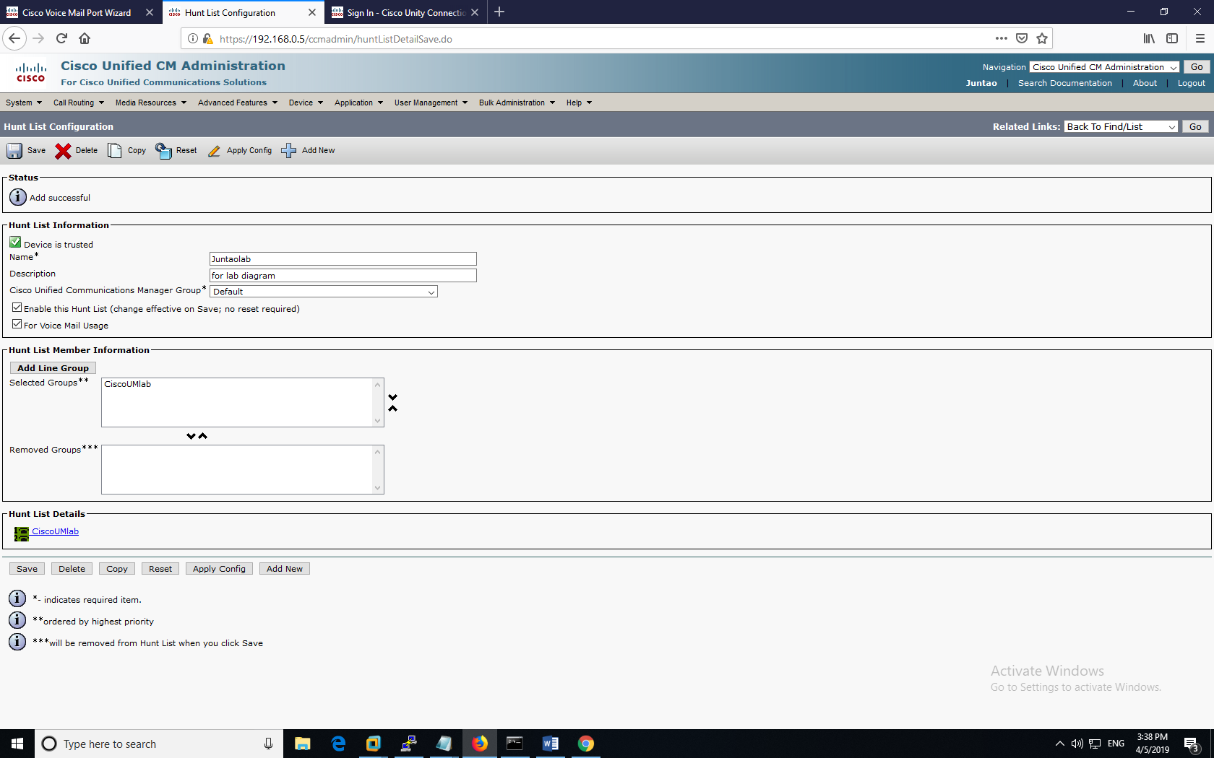

Next step, we configured the “Hunt lists” which would be linked to the two end users shortly.

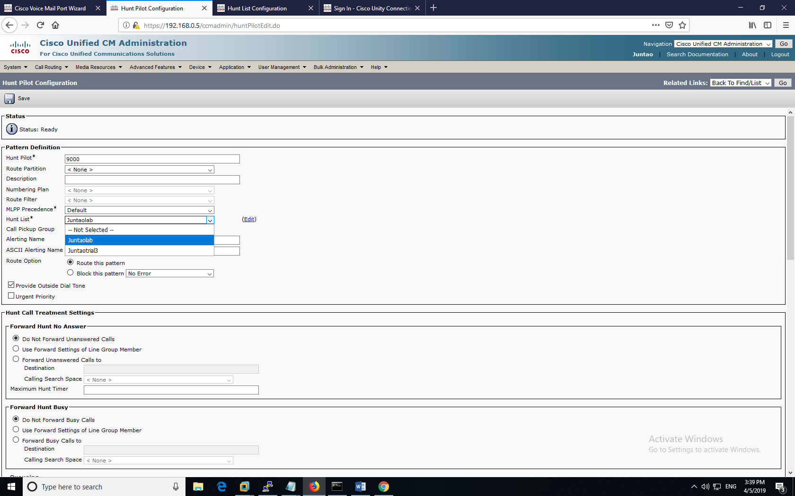

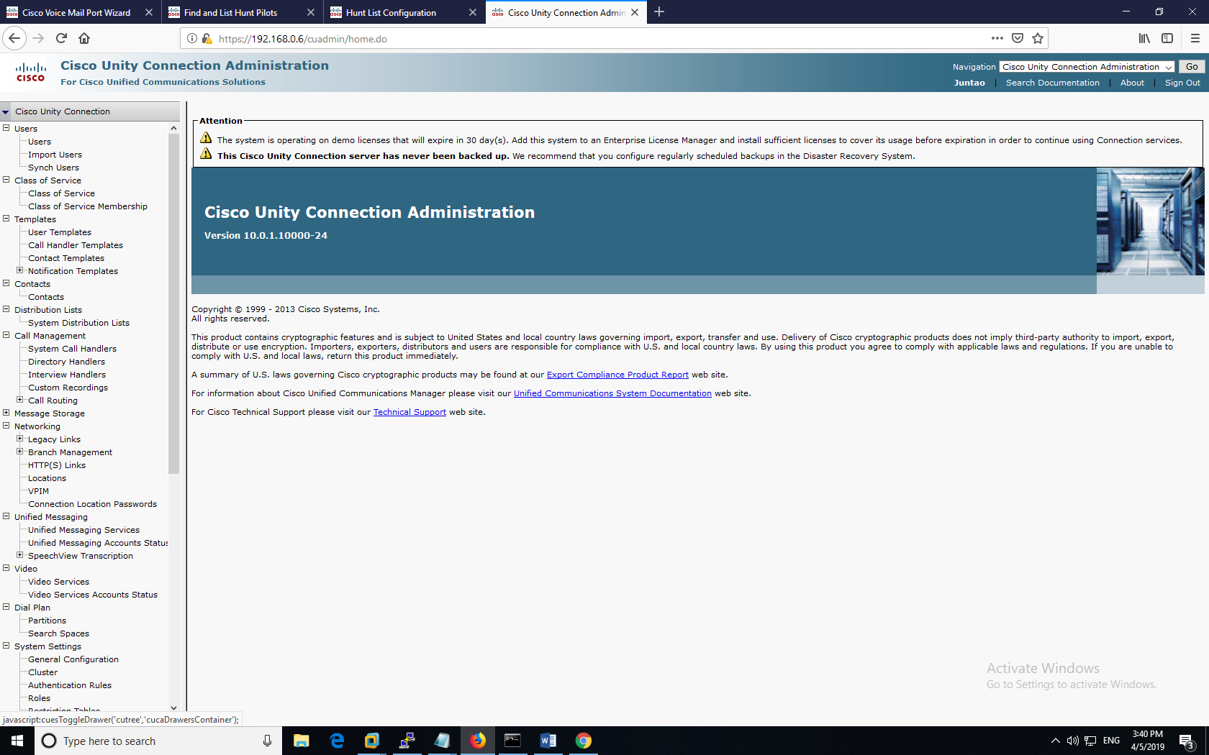

Next, we navigated over the phone system module and began applying our configurations to the two cisco end user phones used within this lab.

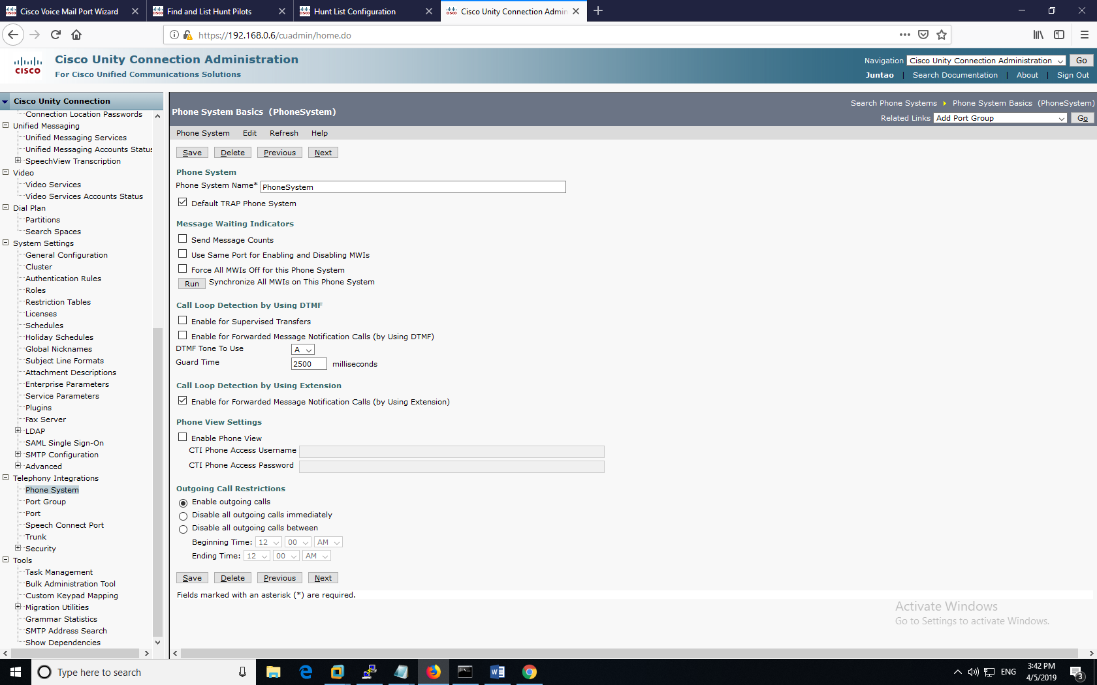

Next, we used SCCP to finish up our associations with the two phones within this configuration.

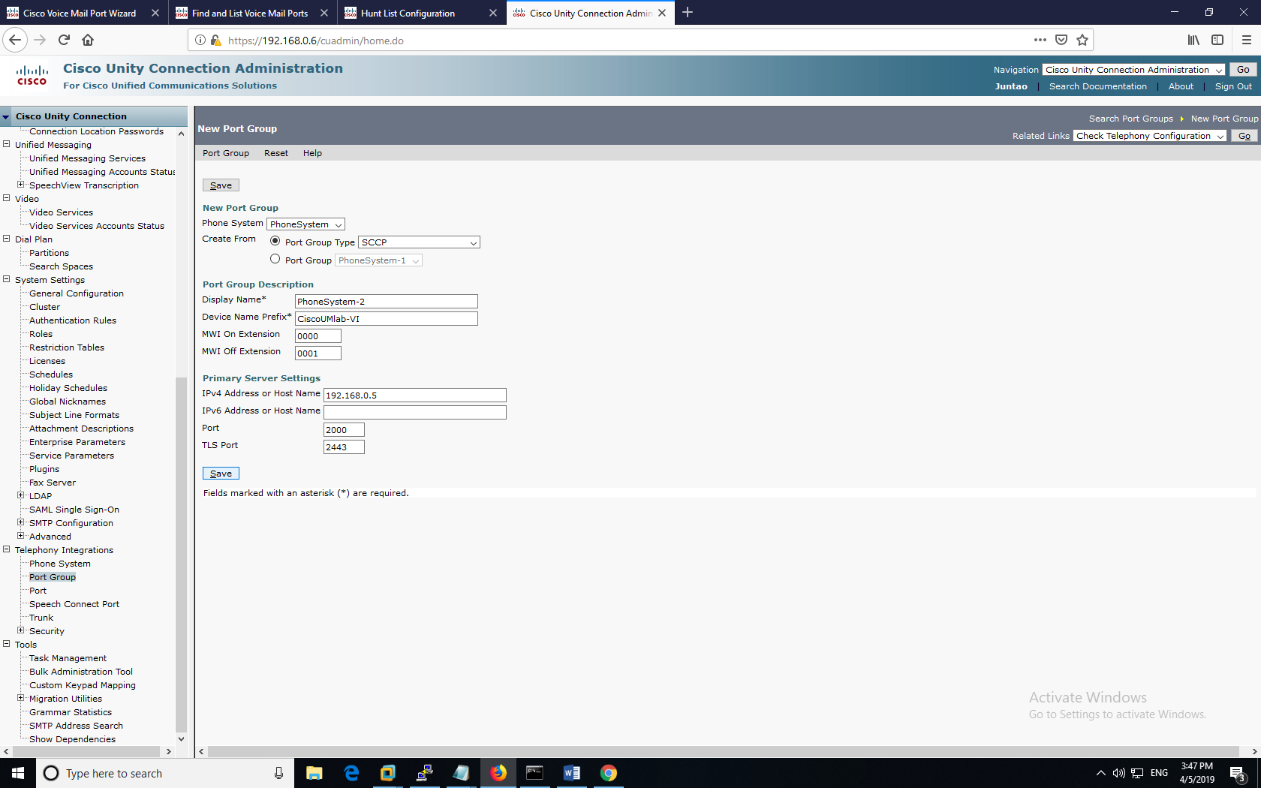

We then defined a custom port group.

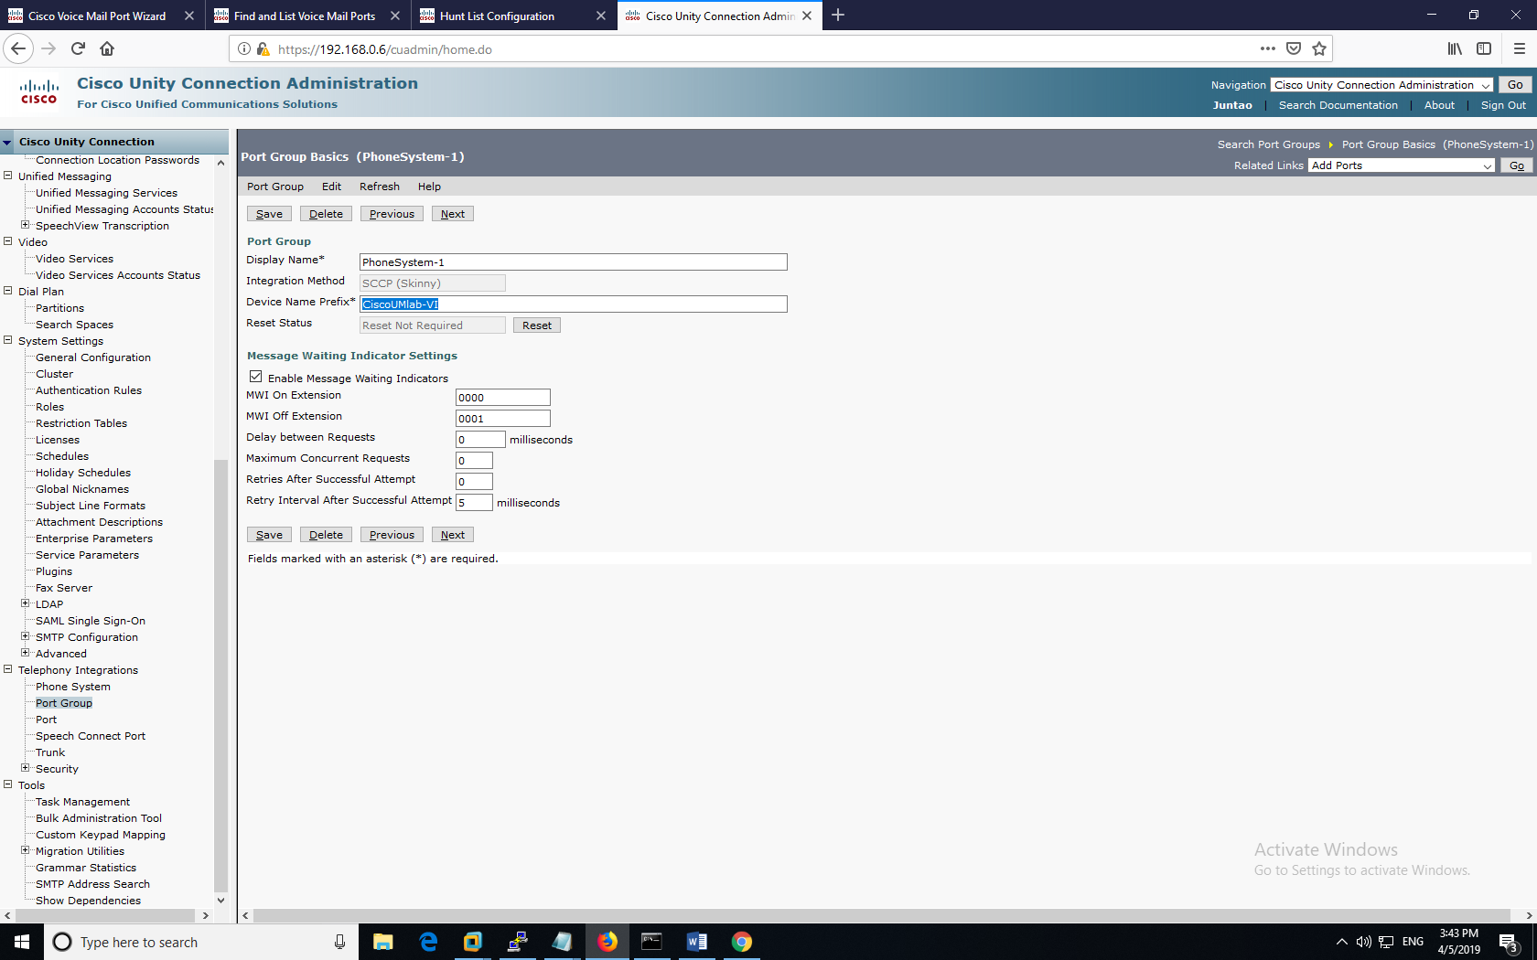

Below is a table for the configurations and settings for review within the CUCM.

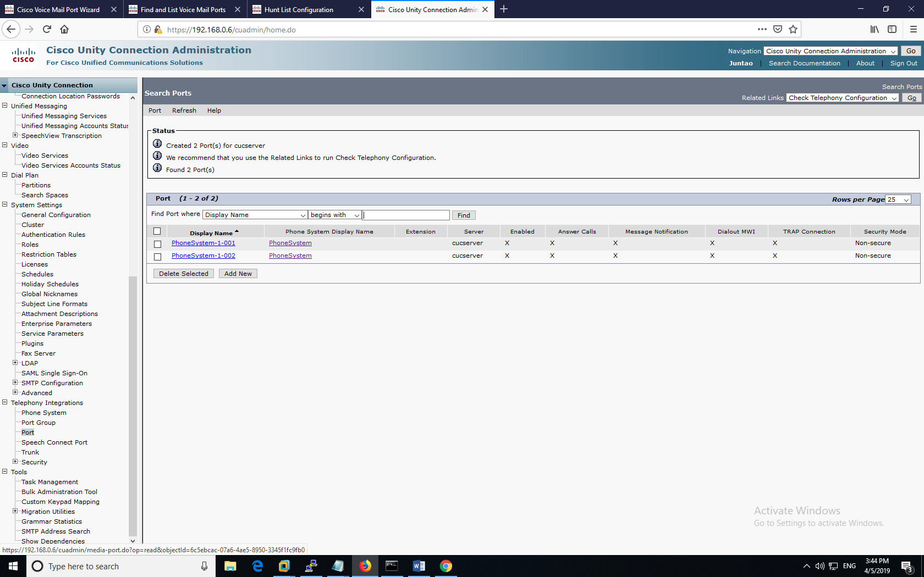

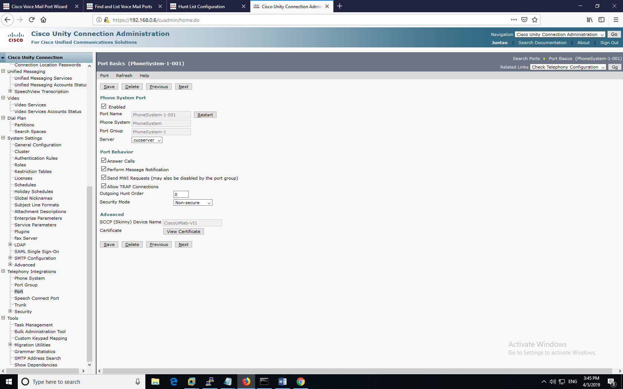

Finally, we defined the user settings and profile for customizability.

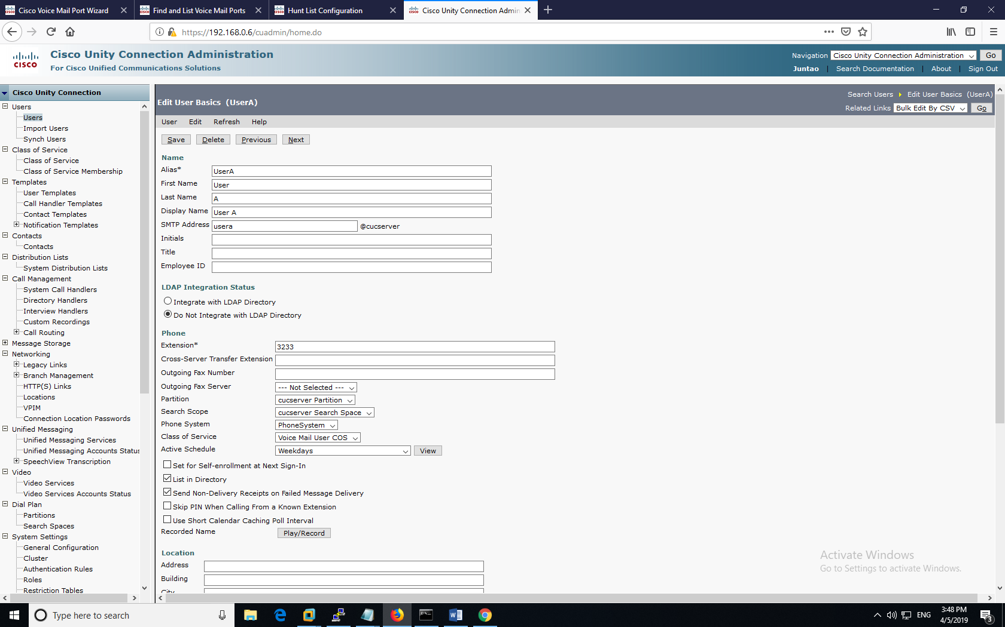

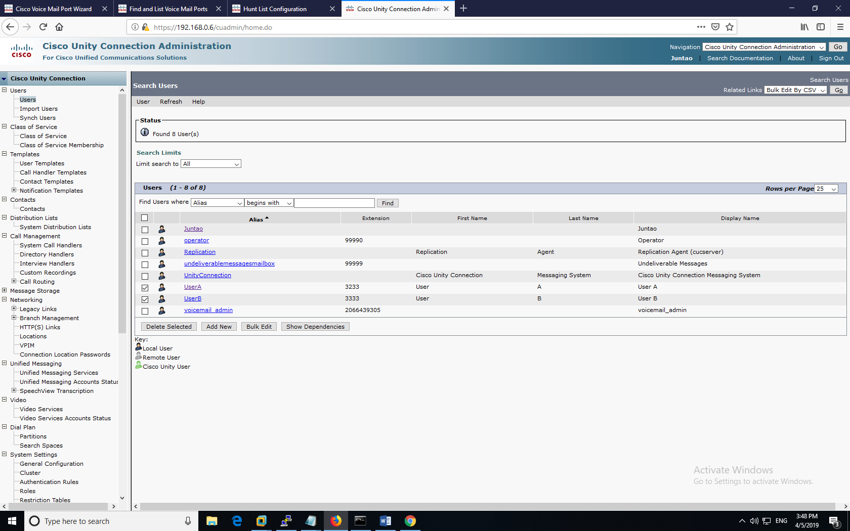

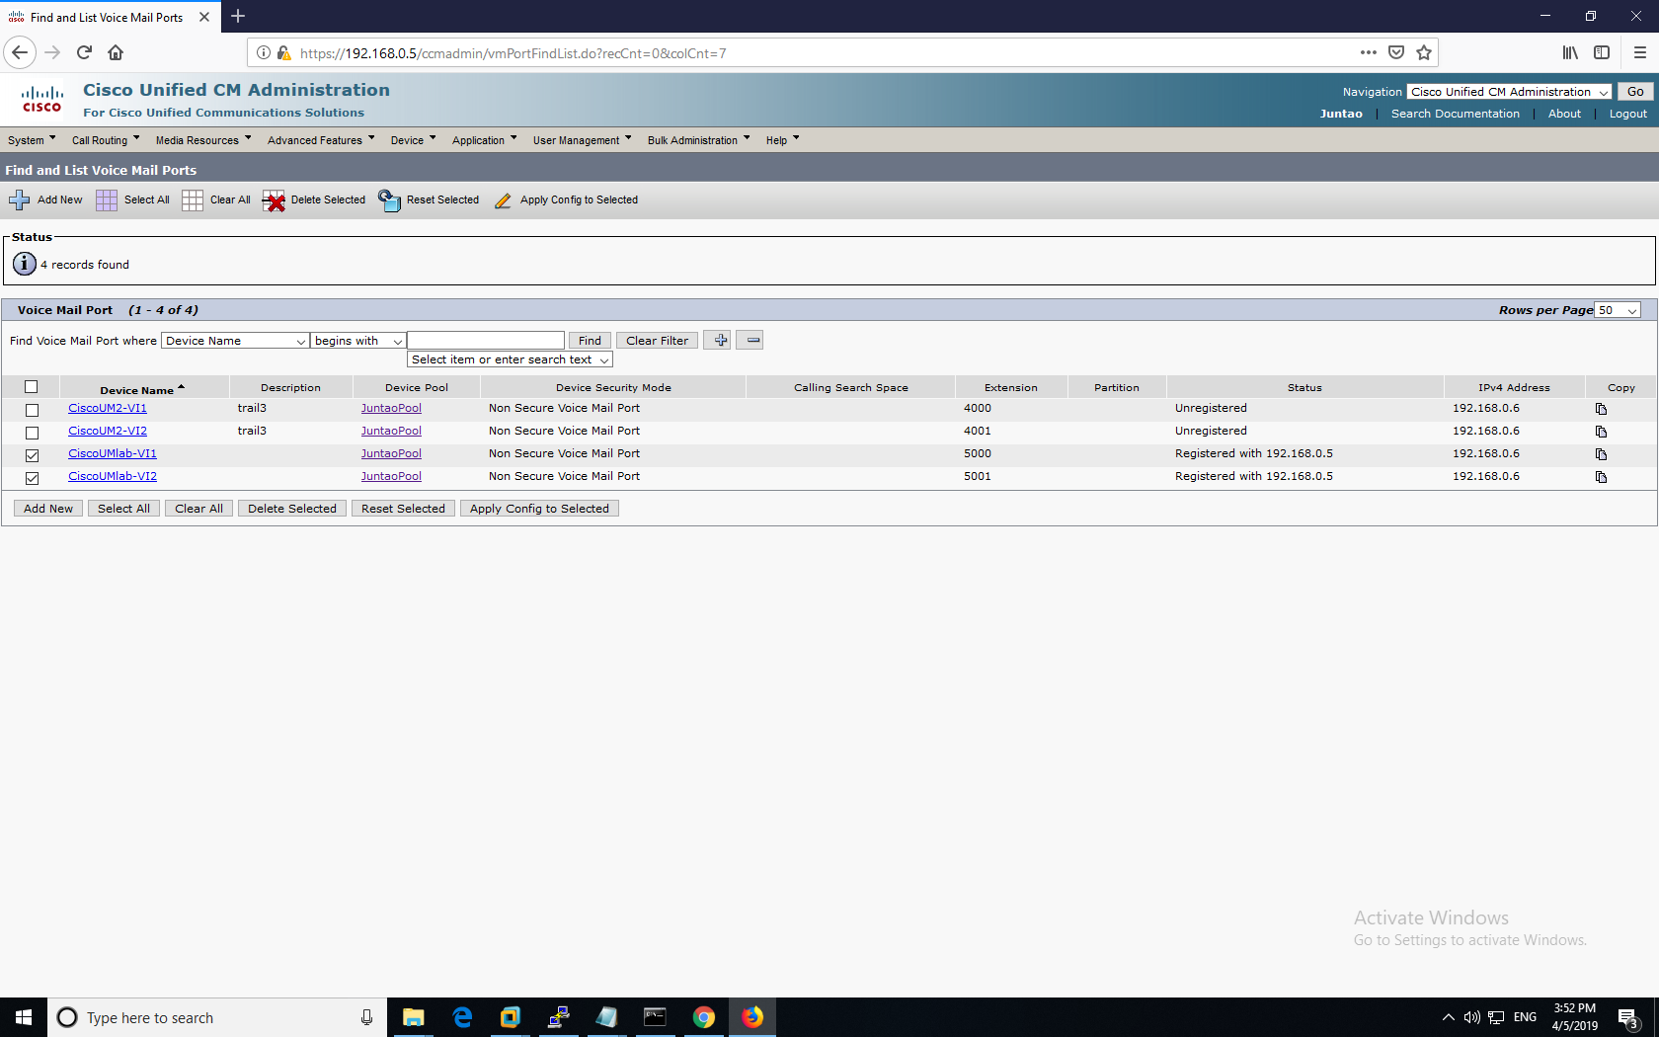

====================================

Configurations

Below is the **router** configuration for the router used within the topology.

version 15.1

service timestamps debug datetime msec

service timestamps log datetime msec

service password-encryption

hostname R1

boot-start-marker

boot-end-marker

no aaa new-model

memory-size iomem 10

no network-clock-participate slot 1

dot11 syslog

ip source-route

ip cef

ip dhcp pool VOIP

network 192.168.1.0 255.255.255.0

option 150 ip 192.168.1.2

default-router 192.168.1.1

no ip domain lookup

ip domain name Warren.com

no ipv6 cef

multilink bundle-name authenticated

voice call send-alert

voice rtp send-recv

voice service voip

h323

voice-card 0

voice-card 1

crypto pki token default removal timeout 0

license udi pid CISCO2811 sn FTX1124A12X

vtp domain cisco

vtp mode transparent

redundancy

interface FastEthernet0/0

no ip address

shutdown

duplex auto

speed auto

interface FastEthernet0/1

ip address 192.168.1.1 255.255.255.0

duplex auto

speed auto

ip forward-protocol nd

no ip http server

no ip http secure-server

control-plane

voice-port 0/3/0

voice-port 0/3/1

signal groundStart

timing hookflash-out 50

timing guard-out 1000

connection plar opx 1111

caller-id enable

ccm-manager config server 192.168.1.2

ccm-manager config

mgcp call-agent 192.168.1.2 service-type mgcp version 1.0

mgcp profile default

dial-peer voice 10 voip

destination-pattern 1111

session target ipv4:192.168.1.2

dtmf-relay h245-alphanumeric h245-signal

dial-peer voice 1 pots

destination-pattern 9T

direct-inward-dial

port 0/3/1

forward-digits 11

telephony-service

max-ephones 2

max-dn 2

ip source-address 192.168.1.2 port 2001

create cnf-files version-stamp 7960

max-conferences 8 gain -6

transfer-system full-consult

line con 0

line aux 0

line vty 0 4

login

transport input all

scheduler allocate 20000 1000

This is the configuration for the Layer-2 switch used within the topology:

Switch 1:

SW1>enable

Switch#show run

hostname Switch

vlan 10

name voice

vlan 20

name data

interface FastEthernet0/1

switchport voice vlan 1

spanning-tree portfast

interface FastEthernet0/2

switchport voice vlan 1

spanning-tree portfast

interface FastEthernet0/3

switchport voice vlan 1

spanning-tree portfast

interface FastEthernet0/4

switchport voice vlan 1

spanning-tree portfast

interface Vlan1

no ip address

Problems

The route partition that was set up wasn’t stable and was constantly being erased. In addition, for some reason, when Ringtone has been set up, initial tests seem successful, but later consecutive days the Ringtone configurations weren’t stable, so there were mismatch errors being displayed. Even though the ringtone has been uploaded to the CUCM server, the ringtone list still displays the two default files. This is caused by the topology being destabilized by repeated load-ins. I didn’t understand the specifications of the file requirements, so occasionally my ringtones wouldn’t load on a phone for being too large. I had the struggle to make a .RAW file with audacity. Voicemail implementation was a headache, since the main issue was that all the configurations required exquisite tuning and attention to detail in order to communicate with other devices. To mitigate this issue, reconfiguration of the voicemail under the SIP Device phone configuration on the CUCM website was required.

Conclusion

This lab aims to teach us how to configure VOIP to route internally between set IP phones within the local topology. With VOIP, workers could communicate clearly through the building that it was set up in and communicate across WANs if the topology is big enough. I also learned how to set up VoIP using Red Hat OS from a virtual machine, to connect two IP phones together. VoIP networks also tend to be a cheaper alternative to traditional landlines outside of corporate networks, since it doesn’t depend on subscriptions to landline services. Integrating CUC with CUCM was a relatively challenging process to figure out though.